**ABSTRACT**

ZnO nanoparticles are regularly studied for optoelectronic devices. By doping, the structural, optical, electrical and magnetic characteristics of the materials are changed. Some nanoparticles, e.g. Al, Ga, Co doped with ZnO have been extensively used. Even so, few Sr-doped ZnO nanoparticles have been reported so far. In the first part of this work, Sr-doped Zinc Oxides nanoparticles have been synthesized by sol gel process. In the next part of this project, the dye-sensitized solar cells (DSSCs) have been fabricated. They have been analyzed with X-ray diffraction (XRD), Scanning electron microscopy (SEM), UV-visible Spectrophotometry respectively, for their structural and optical properties. The functional groups and chemical bonding of ZnO have been substituted by Sr ions by Fourier transform infrared. The particles of varying sizes and shapes were seen in the micrographs. The measurements of photoluminescence indicate a change of 380 to 384 nm for doped and co-doped samples at close-band rims of UV emissions. To decrease the inherent defects in the ZnO structure, the Zn replaced by Sr ions. This has also been observed that there is a saturation benefit of the Sr-doping concentration in ZnO nanoparticles for our primed solar system regardless of the marginally soluble nature of strontium in ethanol. Undoped and Sr2+ doped DSSCs have been used for generating ZnO-based photographic anodes. The charge characteristics of prepared DSSCs have been used in electrochemical impedance spectroscopic experiments.

**CHAPTER 1**

**INTRODUCTION**

* 1. **Nanoscience**

“Nano science is the study of the phenomena and manipulation of materials at atomic, molecular, macromolecular scales, where properties differ significantly from those at a large scale”. Nano science is the study of particles intermediately between the biggest molecules of the present photolithography and the smallest structures, the theory of smallest scale objects, from a hundred nanometres to fewer than 100 nanometres (GaigeZheng, 2004) (Publishing *et al.*, 2006) (Lieber, 2003). Chemistry historically mixed these proportions of colloids, micelles, polymer clusters, phase-split areas of block copolymers and related structures, usually very large molecules or aggregates with many molecules. More recently, special types of nanostructure have appeared, such as Bucky line, silicone Nano rods and composite quantitative semiconductor dots. Nano sciences in physics are generally concerned with quantum phenomena and electrons 'and photons' activity in Nano scale systems. Biology and biochemistry are also involved as a cell part in nanostructures; many of the most fascinating biological structures from DNA, viruses to subcellular organelles and gap interfaces can be found in nanostructures (Bamford *et al.*, 2000). For several purposes, these very small systems are very important. Firstly, we are mystified by many of their properties (Kinosita and Adachi, 2004). How does the electrode travel through organizational nanowires (Wang, 2002). Second, it is complicated to do. Moles are readily synthesized and characterized in vast amounts. It was still difficult to prepare colloid and micelles and lattice nucleolus (in reality, a function that corresponds to a complex colloid science can be rendered often only as mixtures) developing a "synthetic chemistry" of colloids that's as true as molecules is a substantial challenge for chemistry and characterization (Mammen *et al.*, n.d.). The synthesis or processing of arranged colloid arrays and patterns provides another and similarly interesting problem collection. Thirdly, when various Nano scale structures were unavailable and/or off track, the analysis of these structures contributes to new phenomena (Bawendi and Steigerwald, 1990). Very little particles or large, organized, molecular or atomic aggregates are just not structuring that science should research carefully. Fourthly, nanostructures are of different sizes of which quantum effects, of, are relevant in their quantum enclosure and other representations of wave character. Quantum effects, however, are largely veiled behind typical behaviours in macroscopic materials and systems, and they do, of course, essentially form the basis of their properties. Fifthly, one field in biology is the nanometre-sized functional structures that conduct much of the cell's more complex activities. Sixth, the base for Nano electronics and photo-photonics would be nanostructures. Microlithography is the very most important processing technology of today: its progeny, the microcontrollers, and the memories it produces, form the foundation of computer technology that has so greatly changed civilization over the last half century. For nearly 50 years, microelectronic technology has continuously adopted a single Moore law "Littler is cheaper and quicker" is the common term of this rule (Forever and Lundstrom, 2013) (Marsh *et al.*, 2009). "Smaller" excitement as leading philosophy in circuit architecture is cooled lately, and there have been more and more components heat dissipation, power transfer, sync clock, indoor contact. However, technological advances have taken the part sizes of industrial semiconductor devices nearly 100 nm in the semiconductor industry and miniaturization persists unabated. Understanding the actions of materials in less than 100 nm of structure is and will proceed as Nano-electronics. The convergence of the potential of modern scientific phenomenon and the application of a technology of considerable significance is the driving force of Nano science. A less logical type of propels is also possible: Nano science and nanotechnology have become such a platform for futurists who dream about how to be the future and often the two intersect with science fiction (Drexler, 2007) (Phoenix *et al. 2004*). The creative projection of Nano science further into near term has generated ideas both thrilling and disturbing, often without any restraint on the creativity of those trying to project, yet, occasionally, very dumb. The newspapers, the libraries and organizations that defend humanity from thoughtless or no ethical methods have communicated those theories, which have drawn public attention. Nano science has become a symbol of the future of physics. It is both cheerful and worrying; the comparison is both excited the disturbing (Bainbridge, 2002).

* 1. **Nanotechnology**

“Nanotechnologies are the design, characterisation, Production and application of structure, devices and system by controlling shape and size at Nanometre scales.” Nanotechnology is a rising interdisciplinary that has an extensive utilization in all fields of present-day science and innovation. Such fields are optics, mechanics, medications, plastics, materials science, hardware, aviation, and textiles. Because of their fresh, exciting views in many fields, nanoparticles have attracted the attention of scientists from all over the globe. How to manufacture such sophisticated Nano crystals with a well-defined and repeatable electronic and magnetic characteristic at low price has been the most difficult problem today (George *et al.*, 2010).

* + 1. **Existence of Nanotechnology**

Nano science is with us now for a decade. Technologies are just slow to evolve, and in fields such as biotechnology the pace of growth appeared (although it might not be) to be sluggish. The abrupt question is: "Is it a nanotechnology, or can it exist?” “Hell yes!" is the reaction. "What's it? Then will be asked? What is that going to be? Of what shape is that? And would it have a nanotechnology, one or two or many?

Indeed, an evolutionary nanotechnology focused on current materials with micro and nanometer size characteristics is known to exist already. Industrial nanotechnology has been developed and is effective in early year’s safety (Ignatovich *et al*, 2006). The more important question is whether we can now envision groundbreaking nanotechnologies focused on essentially modern sciences. I assume that, but I do not know; they are likely to come out only steadily, as most emerging developments do. The nanotechnology that we now have is microelectronics (where smart engineers have already demonstrated how current microelectronic equipment methods can now be applied to modern structures with cables and part sub-70-nm) (Mulkens *et al.*,2003). Material science (mostly properties of ceramic, polymer and metals are determined by structure of 1-100 nm) (Shenhar *et al*, 2003), and chemistry (where nanometer is nanotechnology, which is a breakthrough Nano, that is to say, innovations originating from modern nanostructured materials whose shape and meaning are still unclear), (e.g. Bucky tube) or from quantum dots' electronic properties, or from radically different kinds of architectures using Nano-devices for processing and storing and transmitting information. There are also Nano-systems which use or imitate biology. There is no doubt about the presence about innovative Nano science in academic labs and the importance of emerging models in nanotechnology. How many of these fascinating, groundbreaking disciplines will move to modern technologies and how fast this transfer will happen still not readily apparent. The history of technology indicates, however, that in the case of a fire, when there are smoke, significant new inventions are inevitably created, when sufficiently new research remains.

* + 1. **Risks in Nanotechnology**

A modern technology generates controversy between those who want to use it as soon as possible and those who want to delay, if needed, to make it completely safe. Nanotechnology is novel; while some are very well-known, others are unknown, and the public is not surprised to be both alert to their dangerous potential and to their positive potential(Whiteside, 2005).

* 1. **Nanomaterials**

Nano materials describe, in principle, materials of which a single unit is sized (in at least one dimension) between 1 to 1000 [nanometers](https://en.wikipedia.org/wiki/Nanometre) (10−9 meter) but usually is 1 to 100 nm (the usual definition of [Nano scale](https://en.wikipedia.org/wiki/Nanoscale)). Nano materials research takes a [materials science](https://en.wikipedia.org/wiki/Materials_science)-based approach to [nanotechnology](https://en.wikipedia.org/wiki/Nanotechnology), leveraging advances in materials metrology and synthesis which have been developed in support of [micro fabrication](https://en.wikipedia.org/wiki/Microfabrication) research. Materials with structure at the Nano scale often have unique optical, electronic, or mechanical properties. Nano materials are slowly becoming commercialized and beginning to emerge as commodities. There are significant differences among agencies on the definition of a nanomaterial (Lim *et al.*, 2010). In [ISO/TS 80004](https://en.wikipedia.org/wiki/ISO/TS_80004), nanomaterial is defined as a "material with any external dimension in the Nano scale or having internal structure or surface structure in the Nano scale", with Nano scale defined as the "length range approximately from 1 nm to 100 nm". This includes both Nano-objects, which are discrete pieces of material, and nanostructured materials, which have internal or surface structure on the Nano scale; a nanomaterial may be a member of both these categories.

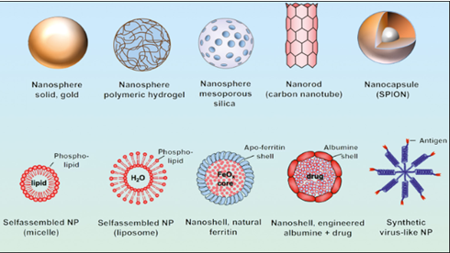

**Figure 1.1** Different shapes of nanomaterial

On 18 October 2011, the [European Commission](https://en.wikipedia.org/wiki/European_Commission) adopted the following definition of a nanomaterial: A natural, incidental or manufactured material containing particles, in an unbound state or as an aggregate or as an agglomerate and for 50% or more of the particles in the number size distribution, one or more external dimensions is in the size range 1 nm– 100 nm. In specific cases and where warranted by concerns for the environment, health, safety or competitiveness the number size distribution threshold of 50% may be replaced by a threshold between 1% to 50% (Search *et al.*, 2011).

* 1. **Nanoscale**

Nuclear scale: 10-15 m or 10-6 nm. Atomic scale: 0.1 nm or 1 angstrom (A). De Broglie wavelength in metals ~1 nm. DNA molecules: 2–12 nm. De Broglie wavelength in semiconductors, mean free path in polycrystalline metal fills 10nm. Viruses: 10 – 100nm. Nanostructures: less than 100nm.

* 1. **Zinc Oxides Nanoparticles**

Particles on the Nano scale consist of the critical role during the formation of Nanotech. Many Nano particles contain properties and various properties from mass metals. These properties are most used in many of the modern applications. For preparing Nano-hybrids different methods are used for making Nanoparticles on a large scale. Some of these methods are listed blew, but the most commonly method used for preparing Nano particles are the solution based co-precipitation process owing to its different properties. Preparing the Nano particles can be used for different purposes such as for the process of fabricating thin layers on the surface of the substrates and then allowed to dry those layers. It is important to carefully study the properties and growth of the fabricated layers of the Nano particles as their fabrication on the substrate strongly depends on the growth of these layers on the surfaces of these substrates. This method is largely based on the process of forming various chemical reactions at lowering temperature this is the reason it is a major part of Nano-chemistry. These Nano particles are responsible for forming the materials having uniform composition and have high purity. The formation of these Nano particles found it used in many applications on industrial level (Li *et al*., 2010).

Zinc oxide is a most stable chemical element which has unique properties and has non-toxic nature that has forced many researchers to study the application of zinc oxide in the field of Nanotechnology. Zinc oxide Nano particles are the most commonly occurring elements which consist of high energy distances at normal temperature and contain high-excitation energy. In the ultra-violet region ZnO could be used for the process of fabricating the thin layers on the surfaces of many substrates. Zinc oxide could be used for the process of fabricating solid-state detectors that finds its huge applications on the industrial level. Owing to the ionization energies of the zinc oxide Nano particles these Nano particles may contain different vacancies in its structure. These Nano particles owing to large energy differences may have many lattice parameters which have different values as described above. The structure of these Nano particles of ZnO may contain closed-packed structure that contains 3-folds geometry directed at different orientations. ZnO geometry may be represented by the different stacked layers that are arranged in an alternate manner along different orientation. Sub-lattices mainly comprise of 4 atoms that are arranged on the unit cells. In the geometry of the zinc-oxide each zinc ion is bonded with oxygen atoms at the edge of the geometrical structure. In other words, zinc ions may occupy different sites in the close packing sub-lattices of anions. Moreover, these Nano particles may derive from many sources that contain different impurities which can affect the properties of Nanocomposites. To overcome these issues many different methods are developed for preparing Nano particles by using solution-based method by using different pre-cursors. Nano particles are prepared by using silica Nano particles that helps in improving the different properties of Nano- science. Most of the work has been carried out by the formation of silica- based Nanoparticles but the detailed study of the properties has been explained by many researchers from past few years. The resulting sample is then allowed to send for the purpose of characterization. These samples are then compared with other composites and their results have been studied. The changes in the significant properties of both the samples are recorded in the form of tables.

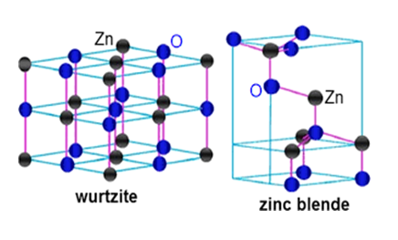

**Figure 1.2** Wurtzite ZnO Internal structure

Schematic chart of unit cell of wurtzite ZnO is appeared in Figure. The tetrahedral coordination in ZnO prompts a need in reversal symmetry and thus, ZnO displays piezoelectricity and pyro-power. Attributable to the wurtzite structure, ZnO has low symmetry prompting unconstrained polarization along the c-bearing. Surface imperfections assume a vital part in the photograph synergist exercises of metal oxides as they increment the quantity of the dynamic locales. At exhibit, the precipitation strategy is generally utilized as a part of the blend of ZnO Nano precious stones on the grounds that the mole proportion can be precisely controlled, mono scatter tests can be orchestrated, and the dissolvability can be expanded. ZnO Nano particles were set up by utilizing a savvy precipitation procedure. The as readied test was portrayed by powder XRD, UV, SEM and TEM examinations and the outcomes have been discussed (Khan *et al.*, 2015). Due to its broad immediate band gap and high excitation binding power, zinc oxide is one of the most promising products for optoelectronic applications. Zinc oxide micro and nanomaterial have been widely researched in recent years because of their size dependent properties. These characteristics allow Zinc Oxide appropriate for making diodes, optoelectronics, and equipment for energy storage and detectors for ultraviolet light emitting. The transmission and optoelectronic characteristics rely primarily on the material's vibrational characteristics, which are affected by interactions between electron and phonons (Rekha *et al.*, 2010). As a broad band range material, Zinc Oxide has concentrated considerable attention on electronic applications. To produce photo electronic equipment depending on Zinc Oxide, both np type Zinc Oxide are required. In the present region Aluminum doped n type Zinc Oxide displays elevated conductivity and optical transparency. It is a smooth conductive oxide that could substitute more costly oxide of indium tin. Also, the Aluminum doped zinc oxide is extremely promising as a future thermoelectric product at high temperatures (Moontragoon *et al.*, 2013).

Due to their numerous uses in the field of spintronics, sensors and photo electronics and light emitting diodes, Metal oxide nanomaterials had been experimentally researched in recent centuries. Because of quantum confinement and increased surface-to-volume ratio, the characteristics of these nanoparticles can be easily changed. Because of its important electrical, magnetic, and optical properties, the semiconductor Zinc Oxide is perceived as host content in the science community among Nano size metal oxides. Zinc Oxide at room temperature has a broad band gap of 3.37 electron Volt, large bond strength and large binding excitation energy (Giovannelli *et al.*, 2014). Zinc oxide distinctive characteristics and advanced implementations in transparent electronics high-tech utilization, piezoelectric devices, ultraviolet light emitters, chemical sensors and spintronics have attracted a great deal of extensive studies. Zinc Oxide has been one of the applicants for electronic and optical instruments as far as nanoparticle is concerned. Zinc oxide usually creates a structure of hexagonal. The absence of a core of symmetry, combined with electromagnetically coupling results in powerful piezoelectric and pyro electric characteristics and the corresponding use of zinc oxide in mechanical actuators, piezoelectric sensors and acoustic devices on the surface wave. In addition, zinc oxide with a broad band gap of approximately 3.3ev and a big excitation binding energy of 60 Mega electron-volts at room temperature is a significant applicant for room temperature Ultraviolet lasers devices with short wavelength (Wojnarowicz *et al.*, 2015). To synthesize zinc oxide Nano powders, solo-chemical method has been attracting material chemist's attention, for wet chemistry as an essential technique, among all the methods. At low temperature, the solo-chemical process has several qualities that can prepare zinc oxide Nano powders at low cost. To obtain high crystallized nan powders with high transparency and thin grain size distribution by using solo-chemical method, without elegant apparatus, expensive precursors and heat treatment at high temperature (Amornpitoksuk *et al.*, 2012).

* + 1. **Properties of Zinc Oxide**

Zinc oxide has formula ZnO and it is an inorganic compound. It is a white powder in appearance and also referred as zincite. It is soluble in different acids like HCl but nearly in-soluble in alcohol and water. This described powder can be considered widely as additive in several manufacturing and the materials like rubbers, cement, adhesives, ceramics, plastics, glass, paints, lubricants, ointments, batteries, pigments, foods, fire retardants and ferrites etc. The wide band gap of ZnO shows several benefits like reducing electronic noise, enabling powder and high temperature operations and raising breakdown voltages. Because of huge surface area, ZnO plays an active role in Nanodevices as gas sensor by enhancing the sensing properties of gas sensors. Also, the bio safe characteristics of zinc oxide make it attractive for bio-medical applications. The direction of etching of ZnO nanostructures is also better, where etching rate is faster along c-axis than radial direction. So, it could be easy to form tubular nanostructures. These results astonish to produce tubular nanostructures having manholes on the walls so that it can show dye or gas diffusion easily into nanotubes (Gherab *et al.*, 2017).

ZnO commonly exists in zinc blende, rock-salt, and wurtzite crystal structures. However, the phase that is thermodynamically stable at ambient conditions is the wurtzite structure and it has iconicity at borderline, between the covalent semiconductors and ionic Semiconductors. The primitive unit cell of ZnO has two formula units in that every Zn ion is hounded with tour ions of 0 showing a tetrahedral coordination. The non-Centro symmetric tetrahedral co-ordination of ZnO produced piezoelectric properties and different crystallographic polarity. It's a main factor for growth of crystal and generation of different defects (Maldonado and Stashans, 2010). ZnO, a semi-conductor having wide band gap, high excitation binding-energy, abundant in nature, n-type conductivity and friendly for environment, is much attractive for various applications like solar cells, photo catalysts, optical coating and anti-bacterial coating etc. Efficient catalytic electrical and optical, properties of the compound zinc oxide can be customized through introduction of relevant and appropriate doping (Nair *et al.*, 2011). ZnO quantum dots are efficient Nano materials. ZnO quantum dots are used as UV-absorbent, luminescence materials and in solar cells because of continuous tunable electronic and optical properties. The uniform ZnO Nano rods give a nucleate surface for production and growth of Cu doped ZnO quantum dots. These quantum dots help to reduce the height of barrier for electrons to reduce the surface of ZnO emitters. At room temperature, ZnO can also provide laser action because of electron-hole plasma. There is also high piezoelectric tensor that owe to the nature of high iconicity of ZnO bond. ZnO tend to take shape in hexagonal wurtzite structure of crystal having space groups (K. S. Rao and Vanaja, 2015). ZnO has been observed to show photo catalysis because it has appropriate band gap, stability against photo-corrosion and high photo-catalytic activity. A few special benefits of ZnO are they show direct band gap, ease of crystallization, easy tailoring of structures, an-isotropic growth and large excitation-binding energy. The rate of recombination of photo-induced pairs of electron and hole in ZnO show important effects in photo-catalytic de-gradation process. Its results are faster than that of surface redox reactions. ZnO nanostructures act as promising photo-catalysts because of highly efficient, inexpensive and nontoxic nature. But its presented broad band gap is a hindrance for its practical photo-catalytic function solar light radiations as it is abundant safe and clean source of energy. To conquer this problem several solutions had been suggested in most recent decade for application of ZnO Nano structured photo catalysts under visible light (Singhal *et al.*, 2012).

To explore the possible co-existence of opto-electronic, Ferroelectricity and Ferromagnetism in a single-phase material is a challenging task. It is essential to find a single-phase material that well matches the silicon for beneficial application in the industry of semi-conductors, ZnO doped Nano powders are inspiring materials for optical, electrical and magnetic properties. These substances arc of great concern due to these applications in transparent electronics, UV light emission, to add property of spin-functionality in (FETs) field effect transistors, low value of threshold spin laser, visitors and surface-acoustic wave properties. In comparison to Ga N and Zn Se, the ZnO is being capable of transformed effortlessly to high large quantity bulked size single-crystals and different thin films having tunable characteristics like optical band gap, resistivity and the property of magnetism by implementing several growths and different doping methods. Due to high excitation biding energy, ZnO shows property of excitonic emission and becomes a potential candidate for the applications related to excitonic laser. Due to direct and wide band gap, wurtzite structure, thermal conductivity and high electron mobility, ZnO becomes proficient for the fabrication of wide range optoelectronic devices (Oves *et al.*, 2015). ZnO have high efficiency than TiO2 in photo-catalytic performance, because of high quantum efficiency. Because of wide band width of ZnO i.e., 3.37 eV it bears an intrinsic limitation with the use of only approximately 4% of UV-irradiation of solar energy, as it is present in large amount, safe and clean source of energy to exhibit photo excitation in photo catalytic progression. So to broaden the answering of zinc oxide for visible irradiation, one of the main strategies is the modulation of zinc oxide band structures to a lower band gap (Bandyopadhyay *et al.*, 2014). There are some imperfections in crystal structure of ZnO and it is critical to understand their behavior for a successful application. These comprise of native point defects, line defects and impurities etc. due to higher concentrations, native point defect is most significant. Native defects include zinc vacancies, oxygen vacancies, oxygen interstitials, zinc interstitials, oxygen anti sites and zinc anti sites. These can be considered as acceptors and donors and mainly depend upon Fermi level, O excess or deficiency and conductivity type. Migration energy is an essential aspect for modeling impurity diffusion and self-diffusion in native-point defects of ZnO. The sum of formation energy for defects (Eli and the migration energy barrier (Eb) is called self-diffusion activation energy (Es). The relation is given as

Es =Ef + Eb (1.1)

The formation energy depends upon experimental conditions like Fermi-level position and chemical potentials of atoms zinc or atoms of oxygen. The barrier of migration energy differs for both equilibrium configuration and the value of saddle point in route of migration. The expansion of activation energies of 0 and Zn self-diffusions from 1.5 to 7.5 eV and 1.9 to 3.3 eV respectively could not be evaluated simply in Zn0. Also, the interpretation and evaluation of Eb, Ef and Es is not straight forward.

* + 1. **Applications of Zinc Oxide**

Zinc oxide is one of the most promising products for optoelectronic applications. Zinc oxide micro and nanomaterial have been widely researched in recent years because of their size dependent properties. These characteristics allow Zinc Oxide appropriate for making diodes, optoelectronics and equipment for energy storage and detectors for ultraviolet light emitting. The transmission and optoelectronic characteristics rely primarily on the material's vibrational characteristics, which are affected by interactions between electron and phonons.Along with nanostructures of different metal oxide, zinc oxide (ZnO) shows its own significance owing to the wide range of its applications. These comprise of different gas sensors, cosmetics, chemical sensors, optical and electrical devices and the storage media. ZnO can also be used as a substitute for those that are related to clipped-wavelength optoelectronics. It can also be used in solid form in blue to an ultraviolet optoelectronic device like in laser developments because of its wide band gap. Moreover, the ZnO has non-Centro-symmetric crystallographic structure because of this it is capable to exhibit piezoelectric property and this characteristic is exceedingly beneficial in the constructing electromagnetic coupled actuators and the sensors (Pradeev *et al.*, 2018).Antibacterial behavior of ZnO NPs has been thoroughly investigated (Brayner *et al.*, 2006). The commonly held method of antibacterial activity of the substance is that the formation of reactive oxygen species (ROS) (Li *et al.*, 2008) on the layer of such NPs in light causes oxidative stress in bacterial cells which ultimately contributes to the death of the organisms. The more reactive hydroxyl radicals (OH), the weaker oxidizer (H2O2) of superoxide anions and the weaker hydrogen peroxide produce ROS. This can lead to damage to DNA, cell membranes etc. (Foster *et al.*, 2011). The binding of the nanoparticles to the bacteria was also seen. That is due to the electrostatic attraction among bacteria with negative charges and nanoparticles positively charged. Of that kind touch can not only prevent the production of bacteria, but also destroy the cell by ROS (Wilson *et al.*, 2001). Both ZnO NPs and Zn2+ have been indicated poisonous, but they have numerous ways to function in cell death. However, the antibacterial properties of alkaline MG2+, Ca2+, Sr2+ and Ba2+ metal ZnO NPs have not been documented to our best knowledge (Manuscript, 2013).

* 1. **Significance of alkaline earth metal doping**

ZnO has unique characteristics that have attracted major researchers ' attention, such as low cost, low toxicity, non-hygroscopic, direct band gaps and inherent emission properties, with large excitonic binding energies (Jayasimhadri *et al.*, 2009). The introduction as a network modifier of alkaline earth metals (Mg, Ca, Sr and Ba) reduces the temperature of the fusion and creates a disturbance in the glass network, which increases the creation of unabridged oxygen groups (Rao *et al.*, 2011). TiO2 is a heavy metal oxide that greatly enhances chemical stability and stable glass structure addition of phosphate glass (Silva *et al.*, 2010). The significant II-VI semiconductor ZnO is an n-type (3.36 eV) suitable band gap with a broad 60 m eV exaction binding energy, which provides a very high-performance application in optoelectronic and nanotechnology applications (Alaria *et al.*, 2005). To monitor their physical and chemical properties for their future applications, syntheses of nanostructure-controlled metal oxide of size and type are very important. In recent years, the optical properties of the Nano crystalline semiconductors have been deeply analyzed because of the small size of the sample and the band distance, changing the optical and electrical properties of the substrate that is ideal for modern applications and products. In addition with impurity atoms or doping is among them being generally known procedure for changing the electrical and optical characteristics of a semiconductor (Yeh *et al.*, 2005). Numerous strategies for the preparation of undoped and doped ZnO nanoparticles, either chemical or physical (Editor *et al.*, 2010), Hydrothermal process (Cai *et al.*, 2008), sol-gel method (Vorkapic and Matsoukas, 1998), co-precipitin method (Manuscript, 2013), have been documented in literature. The co-precipitation process was among the most effective methods for the preparation of nanoparticles among different methods. Magnesium doped ZnO Nano fibers have recently become more common, with the Band Gap Eg being increased, and calcium doping at ZnO NPs relaxing strain at Unit cell. ZnO provides special properties which have attracted the main attention of scientists such as low-cost, low poisoning, non-hygroscopic, direct band distance and intrinsic emissions and broad energy binding exaction. The addition of the Mg, Ca, Sr and Ba alkaline earth metal as network modifier raises the temperature of the melting system and leads to a distortion of the glass structure, which improves the growth of unbridgeable oxygen groups (Rao *et al.*, 2011). TiO2 is really a heavy-metal oxide that greatly increases the chemical stability of the crystal structure and its penetration into the phosphate glass (Silva *et al.*, 2010).

* + 1. **Sr doped ZnO Nanoparticles**

Many methods to improve efficiency were identified by raising the electron recombination between electrons and hydroxide ions. The primary doping is one of that. This raises the pace of electron transportation and allows it possible to raise the substance band difference (Vittal and Ho, 2017). The doped metal ions could serve as a trapping site for electrons, preventing electrons from being recombined. In one-dimensional architecture, the existence of impurity charge carriers can provide better charging for zinc oxides-based dye sensitized solar cells. Various studies are being recorded in metal doped zinc oxides based dye sensitized solar cells (D’Souza *et al.*, 2016) (Goel *et al.*, 2017). Nonetheless, very few experiments with alkaline-doped ZnO earth metal films were reported, of which no experiments with substance usage strontium have been found. Sr2+ has an ionic radius of 2.45Å, far larger than the ion Zn2+, which has a radius of 0.74Å. Since the reimbursement of the costs and discrepancies between the Sr2+ ion radii and the Zn2+ cation, the cation doping creates extraordinary gill defects. The optical properties of ZnO are affected as a result of these factors (Yousefi *et al.*, 2015). Throughout this research, we synthesized and analyzed pure zinc oxides and strontium doped Zn oxides nanoparticles with specific strontium compositions through clear reflux methods.

* 1. **FTO Glass**

Transparent leading oxide TCOs are a technologically relevant material class since they are commonly used on optoelectronic instruments, flat panel displays and electromagnetic safety. Doped fluorine oxide FTO was particularly important because of its high electrical conductivity and optical transparency combined with low cost as a transparently operated electrode in optoelectronic systems. In certain optoelectronic instruments like electrode, FTO is widely used in different kinds of solar cells (Baek *et al.*, 2010). It was not well defined, despite increasingly commonly used FTO in software applications. The FTO mechanism is most frequently referred to, for example, as just 4.4 eV (Shang *et al.*, 2010). FTO was also stated to be an effective anode in organic diode lasers and photovoltaic. Usually, these implementations need an anode that has a working feature of at least 4.7–5.0 eV, which is conflicting with the often-referenced value of 4.4 eV only. This implies that the FTO feature may potentially be considerably larger than expected. In this post, we try to reconcile the big difference in system performing well as the low-work role of Fluorine doped Tin Oxides Based on XPS hybrid radiation spectroscopy and UV spectroscopy, it will be shown that the role of commercial FTO is substantially higher than previously stated. In this regard, it will be seen that UPS controls. The roots of the previously recorded much low work feature are also listed (Helander *et al.*, 2014).

* 1. **Photovoltaic**

Photovoltaic cells are semiconductor devices that turn the power of light into electricity. A semi-conductor is typically a basic part or alloy that, under certain conditions but not always under certain conditions, may conduct electricity and make it a good medium for the regulation of current. Silicone is the group IV factor and the most widely used photovoltaic cell semiconductor. Other products of Group III and Group V (called semiconductors III-V) or of other Group II and Group VI (alternatively, referred to as semiconductors III-VI) can also be used.

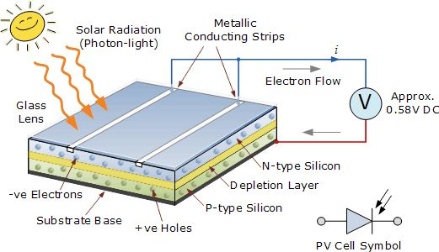

**Figure 1.3** Inside Photovoltaic cell working

For the environment and the oil issue, the usage of solar electricity is of considerable significance. A variety of photovoltaic systems for solar energy usage have been created (Gregg, 2017). According to their peculiar absorption properties of size and form, these photovoltaic instruments include dye-sensitized solar cells (DSSCs) and semiconductor sensitized solar cells (SSSCs) which are attractive candidates (Kamat, 2008). A major emphasis has been put on increasing light collection, improving electron transfer and reducing the recombination of charges to improve the conversion capacity for DSSCs or SSSCs (Anandan, 2007).Solar photovoltaic are a significant source of electricity because conventional fossil fuels have been extensively dependent on for many decades and output cost rises coupled with environmental issues over greenhouse gas pollution. DSSCs have recently been drawn by their low priced manufacturing processes, low toxicity and versatility (Kong *et al.*, 2007). DSSCs consist mostly of a semi-conductive anode containing sensitizer dye molecules, a platinum-based counter electrode and a fluid electrolyte that typically comprises I−/ I3− redox pairs (Soni *et al*., 2015). Photo-anodes are most recently studied in TiO2 Nanostructures. The Zinc Oxide semiconductor may therefore be a replacement for TiO2 since its pre-eminent luminescent and optoelectronic properties have an electron affinity past that of TiO2 (Greene *et al.*, 2006). ZnO has 3.37 eV band widths, 115-155 cm2V−1S−1 strong mobility of the electron, 60 eV heavy bonds strength and photoporation stabilization (Lee *et al.*, 2016). Zinc has a strong conductivity and week frequency of 4.3 eV in addition to the above described characteristics Zinc (Kong *et al.*, 2016). Due to the different architectures of ZnO, many low-cost photo anode designs are possible. Unlike TiO2, the crystalline structure ZnO shows its conductivity and anisotropically increasing, so that nanoparticle photo anodes are more useful in moulding (Baxter *et al.*, 2006).

**1.9 Factors that effects the Performance of PV**

There are several factors influencing the outdoor output of a PV board. Several of these difficulties apply to the module itself, most to the place and climate. Few are the following main factors: solar irradiance, material degradation, module temperature, fill factor, shading, parasitic resistances, tilt-angle, soiling etc. (Vidyanandan, 2017).

* + 1. **Degradation of PV Module**

Solar photovoltaic system manufacturers ensure the module output for 25 years. Guarantors normally guarantee that in the first decade and in the next 10-15 year, the modules will produce at least 90% of their rated potential and around 80% of them. During the first few years of the project, solar panels typically degrade quicker. Overall, the solar panels have an effective rating performance of around 0.5% per year. This mechanism of degradation can be chemical, electrical, thermal or mechanical. Early deterioration of PV modules can be caused by design defects, low material efficiency or difficulties in processing. In most situations, module problems and losses of output are caused by incremental degradation sustained in harsh conditions due to long-term external exposure.

* + 1. **Variation in Solar Radiation**

PV modules can differ greatly in their efficiency under differing light conditions and have a direct effect on the quality of PV systems in turn. Changes in solar intensity falling on the PV module influence many of its parameters, including Isc, Voc, capacity, FF and performance.

* + 1. **Module Temperature**

A PV cell is extremely sensitive to changes in temperature, just as any other dielectric material. The optimized power generated by the PV cell decreases at higher in its temperature. This is primarily because of the increased recombination of internal carriers induced by the higher concentration of carriers. With rising solar radiation and air temperatures, the temperature of a solar cell will increase but will decrease with increasing wind speed. As the cell temperature drops below 25°C, the current marginally decreases, while the voltage and power rise. In total, there is a drop in power output from 0.4% to 0.5% per degree of temperature increase. In conjunction with the kind of semiconductor used, the amount of temperature influences on PV modules can differ.

* + 1. **Fill-Factor**

The PV cell filling factor is known as the relationship between the maximum power and the Voc and Isc product. A high-quality PV module with a fill factor of more than 70% is planned. A lesser factor of fills suggests higher or lower value for Rsh, higher recombination present in space charge and increased Io junction's reverse saturation current, which all reflect increased losses. Cell temperatures are elevated, and the fill factor is decreased.

* + 1. **Parasitic Resistances**

The PV cell series and shunt-resistances, known as parasites, lead to higher I2R losses and thus to reduced module performance. The shunt resistor (Rsh) reflects the resistance to leakage which induces the leakage. Rs must be as minimal as possible for maximum output of a PV node, and Rsh should be as efficient as possible. To track consistency and evaluate the efficiency of a PV device, the awareness of those strength values is important.

* + 1. **Shading**

Shading consists in inconsistencies in the induced currents of each module's cells. The capacity factor of the whole module can be considerably reduced even though partial shades on a single cell. A shaded cell generates much lower current than the un-shaded cell. If more power is pushed through a shaded cell than the shaded potential, it will overheat and may be destroyed.

**CHAPTER 2**

**REVIEW OF LITERATURE**

Silva *et al.*, (2004) studied that nanotechnology can be defined as science and engineering engaged in designing, synthesizing, characterizing, and using materials and instruments, its smallest practical organization on the nanometer scale or one billionth of a meter in at least one dimension. In this scale, it becomes important to take into account individual molecules and interaction groups of molecules with respect to the bulk macroscopically properties of a material or system because it controls the basic molecular structure which allows control of chemical and physical macroscopic properties. Applications of medicine and physiology include structures and instruments engineered of communicate with the body on specifically defined subcellular (i.e. molecular) scales. This will theoretically lead to tailored medicinal treatments of cells and tissues to produce optimum therapeutic benefits with limited adverse effects. Robeson, (2008) reported that polymer-based Nanocomposites are a significant domain of modern research and development that have been explored in the broad field of nanotechnology. The polymer literature has dominated exfoliated clay-based Nano composites, although a variety of other important areas of present and emergent interest exist. It explores the technologies for exfoliation-based clay Nano composites, including barrier properties, flame retardancy, biomedical applications, electronic, optoelectronic applications, and fuel cell interests. The analysis would address many main fields. In the form of glass transformation and crystallization behavior, the main problem of Nano-articles and fiber-inclusion in comparison to their larger equivalents is discussed. Naturally, the advantages of Nano scale filler or fiber inclusion are obtained from other polymer (and composite) based properties and they are shielded. For modern research and development in nearly all technological disciplines the field of nanotechnology is among the common fields. This clearly concerns the science and technologies of polymers and even here study addresses a vast variety of topics. There are a broad variety of topics including composite insulation, shield, fire resistance, electrocapacitive properties, cosmetics, bactericidal properties, including in the area of Nano composites. As prior research before the era of nanotechnology included measurements, Nano technological science is novel, but until recently it has not been related directly to nanotechnology.

Jeevanandam *et al.*, (2018) researched that owing to their tuning physical, chemical and biological properties and improved performance over their large equivalents, nanomaterial has been influential in technical advances. The NMs are graded by scale, structure, type and origin. Growing classification enhances its worth by being able to preview the special characteristics of NMs. If the development of NMs and their industrial applications increases, toxicity problems are unavoidable. The aim of this analysis is to comparison Nanoparticles (NPs), synthetic (engineered), and nanostructured (NSMs) to classify Nano scape properties and to describe the unique information gaps associated with environmental risk assessment. The analysis offers a description of the history and classifications of NMs and an overview of the different sources of natural and synthetic NPs and NSMs and their toxic impact on mammalian cells and tissues in this regard. The toxic reactions of NPs and NSMs are also addressed and laws in various countries are introduced to mitigate risks involved.

Liu *et al.*, (2011) observed that a number of ZnO nanostructured films were produced and employed in dye-sensitive solar cells (DSSCs) as photo anodes, which involve Nano part films, organized pore films, nanotube films and porous Nano films. They outlined their performance in depth and were contrasted. Centered on arranged pore films, DSSCs had a higher efficiency of processing of nanoparticles (0.7 percent) compared with DSSCs (0.2 percent). DSSCs centered on the Nano film were up to 1.3 per cent effective, mainly because of the c-axis directed layout, which could allow for faster freight transportation driving. While wide surface nanotubes is capable of consuming more dyes, the performance of Dye Sensitized Solar Cells dependent upon the film of nanotubes were 1.2 percent and not that of Nano-rod DSSCs, which may be induced by a recombination of load carrier failure in etching defects. Furthermore, the porous ZnO Nano photographic anode exhibited a 2.5x improved performance relative to ZnO Nano samples as a result of enhanced dye loading and fast harvesting. Le *et al.*, (2014) studied that ZnO Nanoparticles have been produced to minimize the catalytically image activities without changing the absorption potential ZnO UV utilizing a co-precipitation process for using ZnO nanoparticles on the sunscreen with a specific Fe content. Fe doping has characterized XRD, SEM, and UV-visible diffuse reflection as the effect on the crystalline structures, geometries, and optical characteristics of ZnO. The catalytic behavior of photography was tested using UV and visible light methylene blue degradation. Fe doping has not impaired the cycle of zincite but has raised cell volume significantly and decreased ZnO particles, as seen by Fe doping at Zn2+ ZnO gill sites. The findings of the analysis indicate that Fe doping did not impact the cycle. Photo catalytic tests show a significant reduction in photo catalytic activity with an increase in doped Fe content, whereas ZnO ultraviolet absorption remains unchained after Fe Doping. The results indicate that Fe doped ZnO is a good UV absorber in practical sun screens. Radzimska, (2014) reported that Zinc oxide may be considered a multifunctional substance due to its special physical and chemical properties. The first section of this paper discusses the most significant methods of ZnO processing grouped into methods of metallurgy and chemical development. The chemical methods to produce zinc oxide include a mechanothermal process, precipitated controlled processes, the Solo-gel methods, solvothermal and hydrothermal method, emulsion method, and a micro emulsion environment and other methods. Within the next section of this report, the methods of manipulating the ZnO were identified. Increases were more frequently found with compounds and polymer matrice organic (carboxylic acido, silane) and inorganic (metal oxide). Finally, in the various industries: rubber, pharmaceuticals, and cosmetics, textiles, and electronics, and electronics, photo catalysts. We present potential applications. This research offers useful knowledge for experts in zinc oxide. Vittal, (2017) showed that the closest alternative to TiO2 is the zinc oxide (ZnO) is a semi-conductive substrate of the dye-sensitized solar cell (DSSC). The reason that both TiO2 and ZnO have similar electron affinities and approximately the same power difference is attributable to Zn Oxides much greater electron diffusiveness than TiO2, strong mobility of electrons, high binding ability of excitation, low-cost, photo-stable corrosion. A broad survey of DSSCs based upon ZnO was introduced and the potential usage of ZnO photo anodes instead of the photo anode TiO2 in DSSC was highlighted. In contrast to those of the TiO2 photographic anode, the ZnO photo anode advantages are explored in depth; it illustrates the key issues and proposes the alternatives. Parameters are developed and solutions are proposed for the improvement of the performance of the DSSC. The discussions are focused on a quasi-solid stable ZnO state and a firm DSSC structure. ZnO as a DSSC semiconductor substrate has its benefits and drawbacks measured. All recorded architectures up to now are cited, and the methods of achievement are listed. In-depth discussion of dyes used for ZnO-based DSSCs. These DSSCs have been found to best be organic dyes and metal-free dyes. The best particle size, its stability and the correct device dimension in the DSSC are explored with data on ZnO and the best redox pair for the DSSC-based ZnO. ZnO animations, which are doped with various ingredients, are strongly stressed. The review also examines several works on DSSCs based on ZnO. The analysis concludes with a definition of MOF use in the ZnO-based DSSC, which has never been mentioned.

Rama, (2017) investigated that the use for indium doped zinc oxide nanoparticles (NPs) with specific concentrations of Indium of the economical and low temperature aqueous solution phase. Spectroscopy of the structure and chemical composition of the sample was defined by the XRD and the X-ray Photo Electron Spectroscopy. The findings revealed that Indium Doped ZnO preserves a structure of the hexagonal ratios and indium atoms are effectively integrated in the ZnO system. Doping with individuals has a great impact on the optical properties of Zn oxides. It was easier to move the electron flow to the electrode owing to reduced internal power and a lack of electron re-combination. The 0.2mm indium-doped ZnO photo anode-based Dye-sensitive Solar cells showed a high photo-current density of 12.57mA/cm2, with an efficient power conversion rate of 2.7% and DSSCs made from ZnO Pure NPs with a current density of 8.02mA/cm2 with an efficiency of 1.8%. The increased surface area and increased light dispersion will be either increased the light extraction capability of the photo-electrode and therefore increase the overall performance of the conversion of solar cells.

Sonker, (2018) reported that a light amplitude difference conveyed by the spherical nanostructures of ZnO (SNS) film at room temperature sensitivity to humidity. The ZnO SNS precursor was then developed and used on borosilicate substrates for the shielding of thin film. The successful low-cost solar-cell molecular systems are effective dye-sensitized solar cell (DSSC). ZnO SNS is a good substrate for the development of DSSC image anodes. The film was then analyzed by means of SEM, HR-TEM, XRD, and UV techniques. It was often used as an optical humidity transmitting monitor of 1,81μW/percent RH gross susceptibility with a reaction period and regeneration period of 36s and 124s. The sensor gave up to 97% reproducible performance. The ZnO SPSs from DSSC are fitted out with a 3mA/cm (Jsc) short circuit current density, a 0,62V open circuit voltage and a 1.3% of sun output. Shanthi *et al.*, (2018) studied that Doped and unopened zinc oxide Nano sections of Li, Mg and Sr were developed by simple mechanism of precipitation. Powder-X-RAY (XRD), Scanning Electron Microscopy (SEM), Transmission Electron Microscope ( TEM), Fourier Transform Infrared (FTIR), Ultra-violent Visible Spectroscopy (UV-vis), Photoluminescence (PL), and Vibrational Sample Magnetometer (VSM) have studied the structuralize, optical and magnetic properties of these samples. The Powder X-ray diffraction evidence demonstrates the composition of both doped and undoped ZnO hexagonal origins. The photograph from SEM shows pores open in a spectrum of 10nm–50nm and particle size. The findings of the FTIR and UV-spectrum indicate the integration in the nanostructure of the ZnO grid of the dopant. The effects of the FTIR and UV spectrums show that the dopant ZnO structure is incorporated in the nanostructure. The rate of photoluminescence varies with doping because oxygen vacancies are increased in prepared ZnO. ZnO is pure, while ferromagnetic property occurs (Li, Mg and Sr). ZnO is paramagnetic. Huang *et al.*, (2020) studied that the need for practical applications is urgently needed for lightweight and broadband microwave absorbents for high absorption power. The compositional and microwave absorption features of LaFeO3 samples was systematically analyzed using a sol gel process using varying quantities of Sr. X-ray diffraction and Riveted experiments have shown that Sr2+ doping can deform the LaFeO3 crystals structure , allowing the Fe-O-Fe bond angle to extend and rotate. Magnetic properties are primarily enhanced by the synergistic effects of the spin tilt angle and crystal structural defects. Oxygen vacancy is created because of changes in Fe3+ valence, as obtained from a photoelectron X-ray spectroscopy study, by the replacement of La3+ by Sr2+. Oxygen vacancies, electronic hopping and polarization losses may be one of the key explanations why electromagnetic parameter improvements are being produced. La1–xSrxFeO3 nanoparticles with Sr adding 0,2 can achieve a minimal reflection loss (RL) of approximately -39,3 dB at 10 GHz with a 2.2 mm spacing and an efficient absorption band wide (RL < -10 dB >) can be about 2.56 GHz. In comparison, with a nominal RL of -36, 8 dB for matched 3.0 mm and Sr content of 0.3, La1–xSrxFeO3 nanoparticles may also achieve a better microwave absorption efficiency in Ca (4–8 GHz). La1–xSrxFeO3 nana sections, particularly with the C-band and X-band, therefore, are promising materials that can be used for high-performance adjustable electromagnetic wave absorbers.

Guerra *et al.*, (2019) studied that ZnO doped and co-doped nanoparticles with Ni and Sr are synthesized using the process of sol gel. The single step of ZnO for all samples was seen by the Rietveld refinement and suggested that structural parameter variations depend on the ion form. The functional groups and chemical bonding of ZnO have been substituted by Ni and Sr ions by Fourier transform infrared. The particles of varying sizes and shapes were seen in the micrographs. The measurements of photoluminescence indicate a change of 380 to 384 nm for doped and co-doped samples at close-band rims of UV emissions. To decrease the inherent defects in the ZnO structure, the Zn replaced by Ni and Sr ions. The visual analysis finds that Zn-Ni replacement diminishes the band gap, while Sr replacement raises the band gap. This importance depends on doping thresholds and the ion form for undoped samples. This work leads to an appreciation of optical properties that could be relevant for potential applications for ZnO nanoparticles co-Doping with Ni and Sr. Yousefi *et al.*, (2015) studied that Nanoparticles of strontium-doped zinc oxide were synthesized with sol-gel (Zn1-xSrxO NPs; ( X1⁄4 0, 0.02, 0.04 and 0.06). Images with microscopic transmission electrons (TEMs) and electron scanning microscopy (SEM) display almost spherical NPs, ranging between 27 and 41 nm, for high Sr concentrations and undoped ZNO NPs, respectively. Raman spectrum revealed that undoped and Sr doped ZnO NPs were crystallized into the hexagon of the rotten structure, as well as chosen Region Electron Diffraction (SAEDs) patterns and Raman spectra. However, the findings from Raman showed that the consistency of the crystal was decreased with a higher Sr concentration in the ZnO structure. Dopant integration proof is shown in the form of X-ray ZnO NPs photoelectron (XPS) spectroscopy. The band gap values for the Zn0.98 Sr0.02O and Zn0.96 Sr0.04 O NPs have declined as the optical characterization findings indicate, while the Zn0.94 Sr0.06O NPs band-gap value has grown in contrast with the undoped ZnO NPs. Observations found that by increasing Sr, but before the ideal concentration, the potency of ZnO photo catalyst activity has been dramatically improved. Wu *et al.*, (2018) studied that Perovskite solar cell is a current photovoltaic technology with excellent performance advancements and fast solution procedures. The production of Perovskite materials free of lead or cut off is a major concern for high-performance Perovskite solar cells. The Sr2+ and Ba2+ are perfect for substitution of Pb2+ in Perovskite film with Goldschmidt's tolerated component, among the alkaline earth's metals. In this analysis we have used Ba-doped and Sr-doped Perovskite to make Perovskite solar cells in standardized materials with differing degrees with doping, including 1.0, 5.0, and 10.0 molar percent. The standardized materials of Ba-doping and Sr-doping Perovskite have a similar pattern in the behavior of absorption and surface morphology. The PCE of SOR-doped Perovskite is only as high as 10.0 molar percent doping levels, but the PCE of SOR-doped Perovskite can be reached as high as 9.7 percent. The photovoltaic properties of Ba-Doped Perovskite solar cells are appropriate to Sr-doped Perovskite solar cells. Ba dopant can slightly supersede the sum of plumage in Perovskite, and it can be a possible candidate in the fields of energy products including plumage or plumbing, Perovskite. Naik *et al.*, (2020) reported that the approach to Zn1-xZrxO (x=0.00, 0.01, 0.03 and 0.05) Nanoparticles mentioned was used to synthesis sol-gel approach. Zr-Doping effects on ZnO nanoparticles' electrical, optical, electrochemical, and antibacterial properties have been studied. For non-operative and Zr-doped ZnO nanoparticle characterization the following research is used: x-ray diffraction (XRD ), Fourier Transform infra - red Spectroscopy (FTIR), Feld Emission Scanning (FESEM), Transmission Electron Microscopy (TEM), UV-Visible Spectroscopy (UV – Vis), and Photoluminescence (PL). The UV–visible spectrum of Zr-doped ZNO samples detects changing of the absorption edge to the lower wavelength and red-shifting of the band difference. The PL spectra had band side, violet; solid blue and green emissions independent of doping concentration, but the strength was increased with doping rate. The Zr-doped ZnO adjusted carbon paste (MCPE) electrode has greatly altered electrochemical efficiency in uric acid individually and at the same time, dopant and superior escape are significantly impacted. Anti-bacterial experiments indicate that the ZnO doped nanoparticles have increased antibacterial activity in contrast with the pure ZnO nanoparticles, both against bacterial gram-positive and gram-negative types. Wang *et al.*, (2008) studied that in opto-electronic applications, Indium tin oxide (ITO) and Fluorine tin oxide (FTO) were commonly used for window electrodes. But such metal oxides tend to become increasingly troublesome because I the restricting supply of the indium in the soil, (ii) the insusceptibility to ionic diffusion into polymer layers, (iv) its restricted clarity in the near-infrared region and (v) the existing leakage of FTO devices due to defects in the FTO structure. (iii) The susceptibilities to ionic diffusion in the polymers. A key aim in the optoelectronic industry is therefore to look for new electrode materials with good stability, high clarity and excellent conductivity. Helander *et al.*, (2014) studied that Doped tin oxide FTO is a translucent conducting oxide, widely used in applications for optoelectronic devices. FTO’s working feature is generally referred to as 4.4 eV, unlike the latest findings from system outputs. The authors calculated the work function of commercial FTO with x-ray photoelectron spectroscopy at 5.0 to 0.1 eV. Due to surface band bending, UV ozone treatment improved the work efficiency by 0.1 eV. The sources of the previously mentioned much lower work function are often explored because of carbon pollution and diminished performance due to UV-induced work.

Sheehan *et al.*, (2015) studied that Dye-sensitive solar cells (DSSCs) are made usable for a wide variety of low-energy applications with versatile substrates. A compact solar cell also provides economies of scale by high volume roll-by-roll processing in addition to lower material costs. A drawback of flexible polymer substrates is that both electrical and optical quality are poorly stabilized and reduced when subject to the thermal processing steps needed to manufacture the high performance TiO2 photo electrodes. This study evaluates Corning's Willows Glass as an alternative to polymer substrate for the manufacturing of flexible DSSCs and evaluates the potential of indium doped tin oxide (ITO). The pressure points and bending radius of this glass enables it to withstand high sinters and is therefore theoretically suited to roll-to-roll processing. DSSCs manufactured using a 10 mm TiO2 mesoporous sheet and N719 dye sensitized display. The lightweight DSSC glass displays a power conversion efficiency of 4.53% compared to 3.09% of the quality values of DSSCs that are produced from ITO coated thick glass which are commercially available. The improved Willow Glass DSSC efficiency is seen in the enhanced filling factors (FF). Cells produced using Fluorine Doped Tin Oxide (FTO) glass substrates using equivalent methods yielded 7.42 percent higher power conversion efficiency because their sheet resistance is significantly lower, unlike ITO, even after the heat treatment. FTO would achieve better performance than normal thicker glass DSSCs, instead of ITO. FSSCs could achieve a higher performance. That is required when vendors will manufacture reproducible electrically conductive FTO coated willow glass.

Kawashima *et al.*, (2003) studied that New transparent conduction films, FTO (fluorinated tin oxide), have been developed with films coated on indium-tin oxides (ITO). The spray pyrolysis method of deposition of these translucent directing films at a substratum temperature of 350°C in ITO and 400°C in the FTO was used. SnCl2.2H2O [ Sn / (In+Sn), 5 to 100] are sprays on a Corning # 7059 glass layer (100*100*1.1 mm3) in the case of ITO deposition, an ethanol solution of chloride indium (III), in Cl3.4H2O and tin (II) chloride. FTO films have been subsequently deposited to prevent the oxidation of ITO films during deposition. FTO deposition of SnCl4.5H2O in the saturated NH4F water solution was performed using the ethanol tin (IV) chloride solution. These modern clear conductive films obtained the lowest resistivity in a wide visible range of 1.4*10-4Ωcm and the optical transmission of more than 80%. These new transparent conductive materials have increased their electrical resistance by less than 10% even if exposed to a high temperature of 300℃-600°C for a 1 hour in the air. Shanthi *et al.*, (2018) Latest studies demonstrate that metal oxide and its semiconductors, built on composites, are excellent mechanical, catalytic, and antibiotic components. Zinc oxide directly is an innovative and environmentally-friendly substance with a direct broadband distance of 3.1 eV–3.6 eV. It was identified as a viable host material, and a huge exaction binding 60 eV was drawn to comprehensive research materials for applications in optoelectronics, sensors and dye sensitized solar cell systems. The ZnO has been used as a wonder’s material for material scientists in many applications and the number of Zn Oxides used in various applications is growing. As a result, its production is growing all the time, and it is a risk for scientists to use Zinc Oxides preparation that has lower running costs, operate at higher temperatures, less time and better properties. In the meantime, selective doping provides an efficient method of enhancing and monitoring the electro-optical characteristics of ZnO nanostructures that are important in their practical applications. ZnO has been doped with components like Li, Al, Mn and Cr. Also identified as very strong wave sensors were Ca and Sr doped Zinc Oxides. Valence 3 elements, aluminum and indium, have also been doped to increase and decrease Zinc Oxides band gap and boost their electrical conductivity by nearly two separate directions, making ZnO a virtuous choice for transparent electronic systems. Liu *et al.*, (2009) studied that Rare earths such as Ce, Nd, etc. were also doped, impacting the band gap. The literature contains many approaches for ZnO synthesis, such as precipitation, micro-emulsion, non-micro-emulsion, radiation imaging, microwave irradiation, mechanical framing, solution combustion, solvothermal aided by a microwave and sol–gel processes. Various physical techniques for preparing Nano-ZnO have been developed, such as pulse laser deposition, transparent vapor phase processes, chemical vapor deposition and vapor transparent deposition. Day to date, several scientists have documented the processing, with rod, flower-like and sheet-like nanostructures, of nanostructured ZnO Nano powders in a spherical manner. The system of precipitation is an important synthetic technology. The crystal grain will grow entirely and economically using this approach and the size of the particles is universal. Our earlier study, based on Fe3O4 nanostructures, was sol gel method and the catalytic, magnetic and optical characteristics of nanoparticles were examined. The efficiency of the doped and non-doped ZnO alkaline metal ions was compared to that of the nanoparticles. This essay summarized the findings of these quantitative studies.

Khanafer, (2013) studied that since new structures with potential applications are possible at Nano scales and particularly in different industries, nanotechnology has received significant attention in the last few years. This paper gives an insight into the use of nanomaterial in the fields of solar energy and desalination. The latest developments in nanotechnology in heat storage systems, photovoltaic systems and solar desalination are discussed in this project. Photovoltaic solar cells improve their performance with the use of nanomaterial’s thus reducing energy and manufacturing costs. According to the Department of Energy in the US there is minimal environmental effect of power generation technology like photovoltaic solar panels. Photovoltaic systems are substantially less likely than traditional equipment to emit toxic air pollution (at least 89 percent) per kilowatt hour. Raj *et al.*, (2016) studied that ZnO and Strontium doped ZnO nanoparticles (2-6 molar percent) were synthesized by co-precipitation process. ZnO and Strontium nanoparticles were synthesized. X-ray (XRD), Scanning Electron Microscopy (SEM), Atomic Dispersive Spectroscopy (EDS), UV-visible, and Photoluminescence (PL) spectroscopies were examined for synthesized samples. Aqueous solution dyed by UV-Vis radiation in photo catalytic tests of Rhoda-mine B (RhB). The XRD Analysis confirms the hexagonal root structure of both samples. The average nanoparticles crystallite size was 29-51nm. A positive direction for pure and SZ-NPs is obtained from the Williamson-Hall plot (W-H) to validate that a tensile strain occurs. The synthesized NPs are observed in SEM images of different type. EDS spectroscopy has confirmed that strontium (Sr) is found in the host array. The optical study indicates doping absorption reduces and transitions marginally to the longer region of the wavelengths. With increasing Sr dopant concentration, the band gap energy decreases by 3.32-3.03eV. The spectrum of photoluminescence (PL) shows that the UV emissions are high close to the NBE (392nm) band-boundary zone and intrinsic defects have contributed to Vis emissions of approximately 400-560nm. Kinetic RhB dye experiments show that the rate of degradation increased with the concentration of the dopant. Improved photo catalytic activity is seen by improved charging isolation, increased visible light density, inhibition of the recombination of the electron hole pair and stronger adsorption of the RhB dye molecule on the SZ-NP surface. In addition, the reductions in the overall organic carbon (TOC) results show that Zinc Oxide doped strontium NPs have enhanced photo catalytic activity.

Ahmadi, (2014) studied that the use of density functional theory as regards energy, geometry and electronic property was explored for the doping of many alkaline and alkaline earth metals in an armchair ZnO nanotube sidewall. Doping methods for alkaline and alkaline metals have been shown to be endothermic and exothermic. Based on these effects, the electrical properties of the conduit, compared to alkali doping, are considerably more susceptible to alkali metal doping such that they are converted by a HOMO – LUMO power space from intrinsic semi-conductor with an energy gap of approximately ~1.11–1.95eV to an extrinsic semiconductor. Doping of alkaline and alkaline metals improves and reduces the tube's work function, which may affect tube surface electron emissions. Search *et al.*, (2009) studied that the nanoparticles doped with alkaline earth metals, doped with Ba, Sr and Ca, have been synthesized by sole gel pathway and are discussed with thermal, mechanical, dielectric and magnetic properties of BiFeO3 (BFO). There are considerably lower temperatures for the signature structural transformations of the BFO nanoparticles. A decrease in doped samples in comparison to the pristine was observed, whereas a reverse trend was observed in the band break. Iron has been found in all doped samples in Fe3+ Valencia only. Our samples demonstrate magneto electrical coupling. Weak ferromagnetism can be found at room temperature for both the BFO nanoparticles doped and undoped with the maximum coercive field value of 1,78 kOe (2.38 g−1), and for BA and Ca doped BFO Nanoparticles (2.38 kOe) with the saturation magnetization. Yousefi *et al.*, (2013) studied that ZnO nanoparticles (NPs) were undoped and group-I elements synthesized using a sol-gel process. An x-ray diffraction (XRD) test and a transmission electron microscopy (TEM) have been conducted in structural and morphological tests for the resulting materials. The XRD findings showed that the products in the sample were crystalline with a hexagonal root-site level. The TEM pictures showed ZnO NPs with essentially spherical forms with a nanometer-sized particle scale. In addition, there was a decline in crystallite and particulate sizes in NPs from Li-doped to K-doped ZnO NPs in the XRD and TEM data. An expansion of the X-ray peak was examined for crystalline growth in ZnO NPs. The size-stream plot system (SSP) is used to research person leading to a peak expansion of undoped and doped ZnO NPs by crystallite measurements and lattice pressure. Photoluminescence (PL) and Raman spectrometers have also analyzed the influence of doping on the optical belt-gap and crystalline consistency. The spectrum of Raman from all ZnO NPs displayed a clear E2 (high) peak. The PL spectrum had a high peak for the electronic spectrum of all ZnO NPs in the ultraviolet (UV) region. With reference to the non-opted ZnO NPs the doped ZnO NP's UV peaks have been red shifted.

Saa *et al.*, (2015) Studied that This research is about an association between the effects of the X-ray photoelectron spectrometer (XPS) and the photocurrent strength of ZnO doped alkaline metals that are performed under visible situations of illumination. A basic sol-gel process synthesized the nanoparticles. NP morphology and structure experiments were performed using X-ray diffraction (XRD) analyses and TEMs. Using UV-visible spectrometer, an impact of doping mostly on optical band space was studied. In comparison to the non-opted ZnO NPs, the absorption peak was red shifted. The current application of the goods was then investigated under a photographic white light source. The findings revealed that doping products increased the current strength of the ZnO NPs. K-doped ZnO NPs therefore displayed the greatest strength of photocurrent. Finally, the O-1S spectrum XPS of the samples held a debate on the photo current observations. Our findings indicate that the ZnO doped alkaline metals indicate great potential for highly sensitive photo detectors of visible light. Stubhan *et al.*, (2011) studied that zinc oxide and doped aluminum nanoparticles of zinc oxide with the size of nanometer were effectively formulated using alkali precipitation technique. SEM, transmission electron microscope and X-ray diffraction explored the nanometer grain size and morphology of nanomaterial. Calculated from 10 molar percent aluminum doped Zinc Oxide, the smallest size of about 25 to 30 nanometers with a spherical form. By raising the aluminum quantity to 10 molar percent in solution, the optical band gap of undoped Zinc Oxide nanomaterial’s rises from 3.16-3.20 Electron Volt. Dong *et al.*, (2011) studied iron doped zinc oxide Nano rod well-ordered thin films array on glass substrate by zinc oxide seed layer with hydrothermal method at several growth time. The result of growth time on Raman shift, structure and photoluminescence was examined. The thin films at growth time of hours contain the Nano rods with a length of 1.02 um and an typical diameter of 27.8nm be made up of single crystalline structure of zinc oxide along [001] direction and Nano rods growth vertically concerned with zinc oxide film. At the growth the thin films have good Raman shift of 15 cm" have small irregular factor 1.17 and to smaller wave number, determined by Raman scattering analysis. There is great donor related photoluminescence in layers with growth time of 5hours that showed by PL at room temperature.

Singhal *et al.*, (2012) studied that synthesized from last decade the copper doped and pure ZnO Nano-powder has attracted the scientists. There were different concentrations of copper used. The morphology shown by TEM analysis was quasi spherical. The solubility limit of copper on ZnO was found to be 10%. Cu Oxides was formed when segregation occurred above this level. It was shown by FTIR patterns that due to ZnO all the samples at 490cm had a bulky absorption band. When Cu content increased the electrical resistivity was decreased. It is found that activation energy for Cu doped ZnO decreased. Thaweesaeng *et al.*, (2013) studied that produced Nanoparticles with Copper doped Zinc Oxide produced by co-precipitation and annealed for 2 hr at 500°C under Ar air. The obtained samples were distinguished by Fourier transform infrared, by powder X-ray diffraction and with energy dispersive X-ray analysis and also with Ultraviolet visible spectrophotometer. The X-Ray Diffraction analysis shows the distinct microstructure of the synthesized nanomaterial’s without altering a hexagonal wurtzite structure. Changing lattice variables, Nano-strain, a tiny shift and expansion in X-ray Diffraction peaks and reducing the energy gap between 3.49-3.43 eV shows the replacement of Cu2+ ions in the Zinc Oxide lattice. The Copper doping content threshold is suggested to be below the 6 percent molar fraction backed by the thorough X-ray Diffraction assessment and the structural variables obtained. Past studies have suggested this Copper concentration limit as below 5 percent. Giovannelli *et al.*, (2014) studied that used to obtain aluminum doped Zinc Oxide particles from saturated cationic solution. The influence of temperature, number of reagents, length of hydrolysis and time were examined. A method of response was proved involving first the precipitation of different hydroxide substances based on the path followed by the formation-recrystallization of the hydroxide material into Zinc Oxide. In the final Zinc Oxide Nano powders, the Aluminum concentration did not exceed from 0.3 percent which corresponds to Aluminum's solubility threshold in Zinc Oxide. The many experimental circumstances make it possible to overcome the morphology of Zinc Oxide particles from isotropic nanomaterials of the several tens of nm, platelets of many hundred Nano scale or needles like particles. A Nano powder inquiry was recorded on Iron doped Zinc Oxide using a co-precipitated technique annealed at 550°C.The specimen  geometric, biochemical and optical characteristics were explored by XRD and SEM with power dispersive spectra assessment, Atomic Force microscopy and Fourier transforming infrared spectroscopy methods.

Ciciliati *et al.*, (2015) studied that synthesized that aluminum doped zinc oxide transparent conductive thin films by sol-gel technique to study the effect of thickness on electrical and structural properties. XRD results displayed the structural properties of the thin films. When the films were condensed then outcomes showed that the improvement of irregularity and disorder among crystalline domains. This activity was compared with the outcomes attained from electrical calculations and when the width of the thin films was improved then the plastic deformation occurs. The initiation of energy, the optical band gap and the carrier movements were affected by means of greater amount of disorder and the developing grain limit. Khan *et al.*, (2015) studied that distilled magnetic semiconductors were of excellent concern owing to the participation of both charge and spin in application of spintronics. It was investigated that the influence of calcination on the fundamental and magnetic characteristics of nanomaterial’s synthesize by sol-gel technique of cobalt doped zinc oxide. At various temperatures varying from 100-500°C, cobalt doped Zinc Oxide nanomaterials were calculated. The calcined cobalt doped Zinc Oxide nanomaterials were characterized by Vibrating sample magnetometer and X-ray diffraction. XRD results confirm the preparation of Zinc Oxide calcined cobalt doped hexagonal wurtzite structure confirmed by the X-ray Diffraction. There is a reduction in crystallite size with higher calcination temperatures. Calcination temperature was noted to shrink the lattice parameters. Ferromagnetic activity with increased saturation magnetization up to 300°C calcination temperature was noted. Rao, (2015) studied that aluminum and copper doped zinc oxide nanomaterials were effectively produced with Sol-Gel technique and potassium hydroxide, zinc chloride and aluminum nitrate, ethanol and copper nitrate as catalysts. The geometric and optical characteristics of nanomaterial were evaluated using X-ray diffraction and SEM. Also related to investigating the geometric and optical characteristics were the results of Copper doped Zinc Oxide and Aluminum doped Zinc Oxide nanomaterial. X-ray diffraction assessment shows that these specimens crystallize in hexagonal wurtzite composition and do not display impurity stage. The crystalline volume of 28.44, nanometer and 6.88, nanometer is acquired from Copper doped zinc oxide and Aluminum doped zinc oxide nanomaterial. Hence reduction in the crystalline volume could be seen with change in doping component. The optical characteristic depends on the type of doping owing to the frequency of the Aluminum bond the Aluminum doped Zinc Oxide particles were stronger as compare to Copper doped Zinc Oxide.

Qureshi, (2018) studied that the method of Chemical Bath Deposition (CBD), at low temperature, Cu-doped and undoped ZnO Nano rods were grown in vertically aligned manner on flexible substrate. CBD is appropriate due to its simplicity, low temperature, and affordability. As morphology, optical and structural properties of ZnO are dependent on preparation conditions, post processing, preparation methods and doping. The suitable substrate is the one that is of low cost, light weight having high flexibility, portable characteristics, and good transparency. The flexible polymer substrate is suitable substrate having all these properties, for manufacturing of optoelectronic Nano scale devices based on ZnO Nano scale rods. The flexible polyethylene naphthalene wafer used as substrate for production and growth of undoped ZnO and Cu-doped ZnO using CBD method. Zinc Nitrate Hex-hydrate, Copper Sulfate Pent-hydrate and Hexamethylenetetramine were used with deionized water for ZnO Nano rods fabrication. The orientation and structure of undoped and Cu-doped ZnO Nano rods was characterized by XRD. Sharma *et al.*, (2015) studied that the elemental analysis and surface morphologies were described by FE-SEM and X-ray spectroscopy. The diffraction peaks of undoped and Cu-doped Nano-rods were in same arrangement with the wurtzite hexagonal structural phase value of ZnO in standard recorded data. It was seen by intense and sharp of ZnO diffraction plane of XRD record that Nano rods growth was perpendicular to PEN substrate. When we go from pure to Cu-doped ZnO, the peak increases which shows Cu improves crystallinity of ZnO rods. The lattice constant 'c', calculated from diffraction peak for pure ZnO was 5.2205 and that for Cu-doped ZnO was 5.2132 A. The size of grain for pure and Cu-doped ZnO rods on PEN substrate was 55.4 and 83nm along the peak respectively. It was also observed bending and mean diameter of ZnO Nano rods increase by increasing doping of Cu but density of that doped ZnO remains almost unaffected. The average diameter of pure ZnO Nano rods was about 66 nm and of Cu-doped ZnO Nano rods was 124nm. The chemical composition was analyzed by EXD. The effective method for characterization of the electronic band structure characteristic and optical properties is measurement of room temperature photoluminescence. The intensity value of UV emission observed increased with amount of doping of Cu in zinc oxide Nano rods, but green emission decreased. The improved luminescence and crystal band was observed by high PL intensity ratio. Srivastava, (2013) studied for functioning Nano devices, an enabling technology is controlled doping into nanomaterial. Facial growth method was accomplished to control the concentration of Cu doping into ZnO Nano rods. The content of Cu is observed to change from value at 0% to value at 10%, by using the step of value 2%, so that the accuracy control of amount of Cu may be better. The obtained results of XRD and energy dispersive spectroscopy proved the systematic Copper incorporation. Photo-catalytic and optical qualities of Cu-doped ZnO were then studied. The result show that photo-degradation of methyl orange can be accomplished with copper doping. On the surface, the impact of multi valences of copper ions can also be observed from results. The results show unique features as shift of UV peak towards longer wavelength, the increase in emission of visible light, the decrease in the intensity ratio of the UV to the visible and there was a shift in emission of visible light from green to orange.

Pradeev *et al.*, (2018) studied environmental standards are followed around the world, which introduced advanced oxidation process, help to remove toxic contamination present in water and wastewater. Photo catalysis has high potential for degradation of inorganic and organic pollutants to make them less harmful under the irradiations of visible light. This research work comprises of method to obtain high crystallized powder ZnO doped with Cu, using co-precipitation method. It is observed from FE-SEM image that has morphology like a cotton ball, having uniform size from 25 to 40nm. The degradation degree was dependent on amount of photo catalyst, aqueous phase pH, initial dye concentration, and irradiation time and photo degradation kinetics. At pH 6.8, the photo catalytic degradation was found maximum for DB 71 dye. The textile residues of coloring industries act as chief pollutants that pollute water and affect badly that aquatic life along with human life. Jongnavakit *et al.*, (2012) studied the easy and effective process for the decomposition of poisonous organic pollutants is photo catalytic degradation that converts them to less hazardous minerals. Due to direct band gap energy and high excitation binding-energy, ZnO is attractive and wrathful in established hi-tech applications like blue, ultra-violet light emitters, surface acoustic wave devices, transparent electrode, photo-voltaic devices, solar cell windows, photo catalysis, gas sensors etc. Copper Acetate Tetra-hydrate Zinc Acetate Dehydrate, Sodium Hydroxide, Hydrochloric Acid were used for synthesis. The characterization of product was done by using XRD, TEM, FTIR and SEM. The result of diffraction peaks showed the ZnO catalyst structure was hexagonal wurtzite having preferred orientation (101). This phase is most stable for ZnO. By increasing concentration of dopant from 0.25% to 1.3%, the ZnO peak intensely increased. Due to impurity, an additional peak was also found. The prepared Cu has excellent catalytic activity using visible light radiations. The visible photo-degradation effect was examined to show pseudo-first order rate equation for DB 71 dye.

Ba-abbad *et al.*, (2013) studied by using deposition method of low energy electron beam, Cu-doped thin and emaciated films were coated on the silicon substrate. It was observed, on band gap value, CU has non-monotonic effect, varying from 2.67 to 3.33eV and increase due to ZnO matrix layer structure having low Cu concentration and decrease because of Cu Oxides presence as separate phase. Using IR spectra and UV-Vis a significant change was observed in ZnO structure due to presence Cu. The electron-beam exposure initiates the intense chemical reaction between target components, and it is highly exothermic. The amount of energy released may be sufficient to further initiate chemical interactions and also for transferring compounds into gas phase. Jayabharathi *et al.*, (2014) studied the multi-step manufacturing need of targets. The unwanted exposure of energy creates defects in formed thin layer. Copper Nitrate is used as dopant source. The reason for choosing Cu (NO3) is that it can be vaporized easily in vacuum after heating. Gas phase is generated to deposit thin films by exposure of targets of electrons having 800 to 1600eV of energy with density of current 0.01 to 0.03A/cm. Zinc dust; Zinc Nitrate Hex-hydrate and Copper Nitrate Tri-hydrate are used. Coating was controlled by quartz crystal microbalance. Using FTIR, IR spectroscopic studies were done by using Cray-50 spectrophotometer. Zinc dust is injected into evaporation zone. The purpose of using Zinc dust is that it increases stability of this process and helps in fast deposition of film. When values of copper are low in coating, there is increase in E, due to changes in matrix layer of structure of ZnO. But at high value of copper, there is decrease because of Cu Oxides present in coating as independent phase. Suwanboon *et al.*, (2008) studied the first time that Cu-integrated ZnO Nano-particles were synthesized with unlike concentration of Cu without subservient post-thermal treatment. To direct structural qualities and the property related comparisons, pure ZnO NPs were also synthesized. Zn/Cu NPs were described by the X-ray photo-electron spectroscopy (XPS), TEM, XRD, vibrating sample magnetometer, photo-luminescence spectroscopy and UV-Visible. For detailed investigation of crystallography was done by Riveted refinement. ZnO/Cu showed ferromagnetic property at room temperature (RTFM). RTFM property in ZnO/Cu is due to Cu ions incorporated into ZnO structure lattice. XPS chemical study shows Cu incorporation as Cu ions. Magnetization gets enhanced by increasing Cu amount. This narrows down the band gap. The present work gives insight about room temperature ferromagnetic property of ZnO nanoparticles. Giri *et al*, (2016) Studied that ZnO can be utilized to increase ferromagnetic behavior in the diluted magnetic semiconductors. Semiconductor metal oxides incorporated with transition metal are called Diluted Magnetic Semiconductors (DMS) and they show property of room temperature ferromagnetism. Smaller band-gap energies were found for ZnO incorporated with Cu along with reduction in absorption band edge. The RTFM behavior of ZnO incorporated with copper seems to be intrinsic and oriented due to substitution of copper ions on ZnO crystal. There can be seen a co-relation between bond structure, crystal structure and RTFM behavior of Cu incorporated ZnO Nano-structures. The present, simple, cost effective, rapid room temperature technique of doing can be tailored to the other TM elements in order to get DMSs having quality of room ferromagnetism. Xia *et al.*, (2011) studied that plane wave ultra-soft potential process can be used to explore density of the states, band structures and absorbed spectra of undoped and copper doped ZnO theoretically. Copper-incorporated ZnO crystalline films are produced by using hydrothermal method. By comparing with unadulterated ZnO, photo-luminescence spectrum of ZnO doped wit Cu shows that the peak of UV emission shifts towards lower energy and the intensity decreases. Furthermore, in blue and green regions, two more emission peaks were centered. It was observed from results that an energy shift happens in both valence bands and conduction bands that narrower the band gap in Cu-doped ZnO than the pure ZnO. Moreover, in theory, near valence band maximum, the impurity levels were also calculated which caused two emission peaks that were centered at near 469nm and 535nm.

Singh, (2016) studied that the donor levels generated when the Zn atoms were substituted by Si and weak p-type transformation was studied on ZnO. It was observed that a very small mismatch in Au or Ag doped ZnO, enhanced that optical transition. It was observed that co-doping of 2N-Ga would create high quality and stable p-type ZnO imaginary and real parts show a certain red shift, Copper atom is preferable for substitution of Zn it increases electrical and magnetic properties and could induce local magnetic moment. Imaginary parts of the dielectric functions and the absorption spectrum showed a red shift behavior. Here the optical properties of the compound ZnO doped with copper are discussed, which was still not resolved. A hydrothermal method was used to synthesize cone arrays of Cu-doped ZnO. A highly pure zinc foil and NaCl in quantity of I molar were put together in autoclave vessel with deionized water and then in furnace for 24h. The ZnO cone arrays were grown on surface of foil. Levels of impurity near CBM lead to difference in PL spectra of undoped and doped ZnO. Singhal *et al.*, (2012) studied that by using solution route, copper doped ZnO Nano particles were synthesized and then annealed in 02, N2 and Ar respectively. X-ray photoelectron spectroscopy and XRD observations showed that the sample had wurtzite structure and there were no additional impurity phases. The magnetization loops were measured for the ZnO samples and showed Ferro-magnetic saturation behavior. Defect analysis was done by photo-luminescence spectroscopy that showed the effects of defects on the origin and nature of ferromagnetism. A crucial role was played in mediating Ferromagnetism of Cu-doped ZnO especially by single ionized oxygen vacancies.

Yoo *et al.*, (2018) studied that non-linear absorption properties and structural properties of films of ZnO doped with Cu prepared by using magnetron sputtering. The characterization of prepared films was done by using XRD and SEM. It was observed that Cu-doped ZnO films maintain wurtzite structure. The measurements of open aperture Z-scan were done by Nano-second laser pulse. A transition to reverse saturable from saturable absorption was observed by the increase of excitation intensity. The goodness of non-linear optical coefficient shows the sample could be potential application in optical devices. The fabricated sample shows ZnO characteristic diffraction peak (002). It also shows that c axis preferred orientation in fabrication of thin film sample. By the increase of direct current power, (002) peak intensity increases firstly then decreases to the maximum 4W. This effect is due to controlled moderate Copper quantity. The atoms of Cu exist as interstitial and shared oxygen atom with atoms of Zn so thus the value (002) orientation improves. The intemperance number of atoms of Cu can be strongly encouraging for the formation of metallic copper cluster. The change in intensity of peak characteristic of Cu-doped ZnO films shows the qualities the reason of difference in radius of Cu2+ and Zn2+ and the difference of electro negativity that causes distortion of lattice. The average sizes of crystals 24, 21 and 16nm. By the results of SEM, it was seen that the size of grain was not uniform on the surface of undoped ZnO film. But the Cu-doped ZnO films show a smooth surface and uniform grain size. The substitution of Cu increases crystallization. The results of absorption spectra and the results show the value of band gap as 3.17, 3.20, 3.22eV, for obtained thin films that are made of Cu-doped ZnO at the powers of 8W, 4W and 2W of direct current. The red shift was also observed. To observe that the non-linear absorption behavior of films is the function of input-energy, open aperture Z-scan was performed by using Nano-second pulse of energies 1.6, 1.4, 1.0, 0.6, 0.4mJ.

Chitra *et al.*, (2013) studied the effect of different operational parameters like solution pH, initial diazinon concentration, dosage of Cu-doped ZnO Nano rods, nitrogen and oxygen gases and H2O2 concentration were studied by doing photo catalytic experiment and using ZnO Nano-rods doped with copper. As an optional-pH condition, neutral pH was chosen because of photo, corrosion effect of ZnO in basic and acidic conditions. The organic-phosphorous is one of those used widely in the world. The water system contaminated by diazinon must be treated with better techniques like absorption, membrane process and chemical coagulation. Bioremediation, photo catalyst and advanced or conventional oxidation processes.

Baskar *et al.*, (2016) studied Nano-catalyst processor used commonly for removal of dangerous, toxic compounds. ZnO has unequaled physical properties like conductivity, pie ZO electricity and magnet. ZnO shows transparent properties to visible range. But pure ZnO has some limitations as a photo catalyst like fast rate of recombination of generated positive hole and electron. So, it is necessary to decrease recombination rate for electron and hole. To enlarge transparent conducting oxide property of ZnO, this is doped through various metal ions like Cu, Ni, Ga, Co, Al, Sn and Y. The substitution of Cu to ZnO modifies its electrical, optical, photo catalytic activity, magnet and gas sensitivity properties. There is limited information available for the removal kinetics and efficiency of diazinon with illuminated ZnO Nano-rods doped with copper. In environmental photo-catalysis field, study has been done on ZnO Nano-particles, where high photo-catalytic efficiency is noticed with large ratio of surface-to volume by decreasing particle size. But in practical photo-catalytic process, it is difficult to separate finely powdered photo-catalysts from reactor. Now efforts are made to find low cost easily recycled and high active ZnO based photo-catalysts. Cu-doped ZnO having Nano-rod structure can be collected easily from solution. This can overcome disadvantages of ZnO as Nano-catalyst. The capacity of photo-catalytic degradation of diazinon was investigated. Photo-catalytic kinetics in UV/Cu-doped ZnO was better fit with first order model. So, IV/Cu opened ZnO process is efficient than UV/ZnO in degradation of diazinon because it has low rate of electron-hole recombination. After five cycles, photo-catalytic activity was similar. Very good photo-stability, high photo-catalytic activity and easy gravity-separation of ZnO Nano-rods doped with copper will make their application easy in waste-water and water treatment and other environmental photo-catalysis field. Chen *et al.*, (2010) studied the pulsed magnetic field; Nano sized ZnO doped with copper synthesized, by, hydrothermal, method. XRD result showed the hexagonal wurtzite, structure of pure ZnO. The pulsed magnetic field application increased the content of oxygen vacancy and level of doping of Cut when observed by X-ray photo-electron spectroscopy and Raman spectra. The ferromagnetism origin is quality of vacancies of oxygen induced with Cu+2 Ferro-magnetic coupling. Dilute magnetic semiconductors have fascinated the interest of different researchers because of their spintronics device applications with combined magnetic and electronic behavior. Doping of parent semiconductor with transition metal is efficient method of diluted magnetic semiconductors and the novel properties like magneto-optical properties, Spin Hall Effect and giant Zeeman Effect. Copper Chloride and Zinc Acetate were used for synthesis. XRD was performed by using Cu Kα for the analysis of crystal structure and phase composition.

Ciciliati *et al.*, (2015) studied the observation of crystal defects of sample, a Raman spectrum was used. XPS was utilized to analyze arrangement environment of Cu, Zn and O present in prepared sample. Vibrating sample magnetometer (VSM) was used to measure magnetic properties in range from -104 to 104 De. The higher shift of peaks of Cu-doped ZnO, show the enhancement of pulsed magnetic field due to ions of Cu substituted on Zn+2 sites. SEM described the morphology and micro-structure of synthesized sample. Both samples showed hexagonal rod-like morphology. The Cu-doped ZnO-OT branched at ends with diameter about Sum and Cu-doped ZnO 4T was reduced about 3 pm. EDS was used to analyze the existence of ions of Cu in ZnO crystal. Raman scattering calculations were done in wave is range of 200 to 900cm. It showed strain stress states, phonon properties and vacancies. In-direct interaction between dopant ions and oxygen vacancies from magnetic polarons overlapped to generate room temperature Ferromagnetism (RTFM). The increase in oxygen vacancy produced additional magnetic polarons and increased magnetic order. The oxygen vacancy in ZnO matrix is said to be the origin of Ferro-magnetism in copper doped ZnO. Bharadwaj *et al.*, (2018) studied that undoped, and Cu-doped, ZnO Nano-structures were produced by micro-wave assisted method. The optical and surface qualities of both particles were discussed. The characterization of undoped and doped ZnO was done via using UV-vis, SEM, FTIR, EDAX and XRD, SEM declared the Nano-flowered shaped and Nano-needle shaped Nanostructures. Analysis of EDAX confirmed the purity of prepared Nanostructures. The typical size of undoped ZnO particle was about 15nm and was calculated by Scherer formula using XRD. Copper nitrate hexahydrate and zinc nitrate hexahydrate were the chemicals used for synthesis. The micro-eave oven of 800W power was used for irradiation of sample. It was observed that ZnO Nano-crystals grow faster along c-axis. Srinivasulu, (2017) studied that due to low surface energy along c axis. The pure ZnO showed needle-like morphology but the addition of copper causes the formation of Nanoparticles having Nano flower morphology. The atomic percentage of Zn was 11.49 and that of O was 88.51 in pure ZnO. The atomic percentage of Zn was 33.80, that of Cu was 1.26 and that of O were 64.94 in Cu-doped ZnO. The FTIR shows result of spectrum ranging from 4000 to 400cm". The observed peaks supported the large excitation-binding energy and excellent optical properties of synthesized Nanostructures. The Cu addition in ZnO increased absorption wavelength to 337nm for undoped and 352nm for doped ZnO. The broadness of peak in spectrum shows formation of small sized particles. The obtained particles are prospective application in the area of medicine and energy. Garcés *et al.*, (2015) studied that ion beam aided Cu doped ZnO film was set down on un-heated glass substrate. This was done through the simultaneous DC and RF magnetron sputtering of zinc oxide and Cu respectively. Then films were annealed thermally at 200°C for an hour. Here is a systematic way of thermal annealing and ion beam assistance effects on optical, structural and morphological qualities of Cu doped ZnO films. The XRD results showed that films that were deposited were polycrystalline having (002) as pre-dominate orientation. In the hexagonal wurtzite configuration, ZnO was crystallized at right angles to surface of substrate along c-axis. Ion beam assistance of Cu-doped zinc oxide films influenced pre-dominant (002) reflection. Additional energy diffusion was obtained by ad atoms during the growth of films enhanced the concentration of Cu in ZnO lattice and it disrupts the (002) reflection. The surface morphology films showed the hexagonal and granular shaped granules that were vertical to substrate. With the effect of ion beam assistance, optical transmittance of annealed and as-deposited decreased. But optical absorption edge transferred towards larger wavelength and it reduced band gap energy.

Sharma *et al.*, (2015) studied that during the film deposited by instantaneous DC and RF magnetron sputtering of Cu and ZnO, as external beam of ion assistance was varied as discharge current and voltage function. The given voltage and current increases the offensive attack of flux of argon ion on surface of substrate. The application of ion beam assistance on Cu doped ZnO films altered the pre-dominant (002) value orientation to (100) value direction and (101) direction. The increase in ion beam assistance enhanced the concentration of Cu in ZnO by substituting Cu+ ions at invariable DC-sputtering having power of amount 4W supplied to a Cu target. It was observed that by the raise in the grain height, there is distortion of pre-dominant reflection (002). There is decrease in optical transmittance of films (as deposited) with the ion beam assistance effect. Non ion-beam assisted Cu doped ZnO films have optical band gap of value 3.14eV and at higher voltage and discharge current 130eV and 0.25A, it decreases to 3.05eV. So the resultant annealed films show enhanced crystalline nature, RMS roughness, grain size, optical band gap values and reduced micro strain than as-deposited films. Haidoux *et al.*, (2008) studied that Cu-doped ZnO micro balls were achieved through oxalate assisted sonochemical way. FESEM and XRD showed that Nano sheet like structures were assembled and they were forming micro balls of 2 to 4um diameter room temperature photo-luminescence spectra showed that near-band emission was centered 300nm. The absorbance spectrum shows a red shift in direction of the UV-region on nearly at 390nm. The absorbance spectrum shows a red shift in direction of the UV-region on substitution of copper on ZnO. The manufactured goods show extensive light absorption. They show brilliant capability of photo-degradation driven by the sunlight, towards Rhodamine B and Methylene blue dyes. The XRD of pure and 3% copper doped ZnO shows intense and sharp peaks that exhibits the quality of high conductivity. The assembly of a large number of Nano-sheets forms a spherical shape. The thickness of Nano-sheets is about 50 to 100nm. A close analysis of Nano-sheet network shows that there is 50° to 60° angle between the adjacent sheets. Oxalate used in process, act as capping agent. The synthesized copper doped ZnO micro-balls have mesoporous structure and large surface area. Due to these qualities they provide efficient transportation and diffusion of degradable hydroxyl radicals and degradable organic molecules, which makes high photo-catalytic activity.

Fu *et al.*, (2011) studied that detection of biological species and chemicals is an issue to human safety and health. Synthesis of copper doped ZnO is performed at 95°C by hydrothermal method. These synthesized ZnO were short dimensional rods, efficient for standard room temperature sensing and have increased sensor functioning. SEM, XRD, XPS, photoluminescence and Raman were used for characterization of materials. To compare the suitability for gas detecting application, of undoped and Cu doped ZnO rods, a double-rod device was fabricated that used Focused Ion Beam. It was observed that Cu doped ZnO rod sensors showed faster response time, enhances room temperature sensitivity and excellent sensitivity. Nano sized Cu doped ZnO rod-based sensors act as promising candidate for efficient detectors and show low power consumption. Ali *et al.*, (2015) studied the electrical resistance change in old gas sensors was due to targeted-gas molecule interactions with ZnO Nano-rod surface. But those were slow in response, had selectivity and sensitivity issues. Also working at high temperatures may burn H, in air. Now ZnO Nano-rods show improved performances and have room temperature working foe detection of H2. By doping of Cu on ZnO Nano-rods, all these properties and integrated compatibility can also be enhanced. It was noted that by increasing the concentration circuit compatibility can also Cu, the intensity of pea For chemical analysis, intensity of peaks of ZnO decreased that was due to crystallinity decrease of ZnO. For chemical analysis, XPS was used. The elements Zn, O, Cu, N and C. XPS also showed the increase in oxygen range in Cu-doped ZnO sample. Raman measurements confirmed the absence of Cu O and Cu Oxides peaks. The pure and Cu-doped ZnO showed wurtzite structure. The broadness and weakness of E, mode line of Raman is confirmation of presence of copper 700 structures. The photo-luminescence band related to Cu was seen as broad band having maximum about 2.4 to 2.5eV and with 3% Cu-ZnO. It shows emergence in low temperature spectrum. It was the first time that a bottom-up approach was used for fabrication of double rod-based sensors through using in-situ-lift-out technique. The samples showed 44% enhancement in H, sensitivity.

Suresh *et al.*, (2018) studied that catalytic Nano-particle functionalization on sensing layer of semi-conductor metal oxide is effective method to improve their selectivity and sensitivity for the formation of sensors having better working. It is a grand challenge to obtain homogenous and smooth distribution of Nanocrystals on surface of semi-conductor metal oxide because; the SMO based sensors for gas sensing are highly influenced by distribution and size of catalyst. By using Apo-ferritin a protein caged template, well distributed catalytic Nanoparticles on one dimensional semi-conductor metal oxide Nanofibers can be fabricated. In Apo-ferritin assisted method, simply by replacement of precursor can be used to synthesize precious catalyst like Pt as well as non-precious catalyst like Cu and La can be synthesized successfully in Nano scale ranging from 3 to 5 nm. The catalysts encapsulated by Apo-ferritin show high dispersion property because of force of repulsion between protein shells. Due to this reason, catalytic Nanoparticles were decorated homogenously on ZnO Nano-fibers after electro-spinning that was followed by calcinations. Catalytic copper Nanoparticles and platinum Nano-particles functionalized ZnO Nano fibers shoe approximately 2.95-fold and 6.38-fold that was an improved acetone response as compared to pristine ZnO Nano-fiber's response. The present work demonstrate a robustness of synthesis and functionalization method by using bio inspired protein templates combination with electro-spinning technique and a potential of using a non-precious analyst to produce collection of diverse sensing material which can be applied for the cognition of breath pattern to diagnose diseases. Semi-conductor metal oxide-based sensors are of great importance great importance due to cost effectiveness, miniaturization, fast analysis, and the use of simple operating principle that is change of resistance of signals. But semiconductor metal oxide-based sensor has challenge for detection of sub-ppm level for gas with large selectivity and sensitivity in exhaled breath.

Silva *et al.*, (2015) studied that copper doped Nanowires were synthesized by annealing. Cu, doped Nanowires were synthesized through CVD i.e. chemical vapor deposition and by CBD i.e. chemical bath deposition. Results of TEM showed that by the doping of copper, periodic undulations were produced on the exterior layer of both CU-doped ZnO Nano-wires synthesized by CVD and CBD methods. This changed the tensile and compressive strain. XRD showed (0002) peak of Cu-doped ZnO. NWs prepared by CVD can be folded to major peak that is transferred towards lower energy. But peaks of Cu-doped ZnO prepared by CBD are shifted towards lower angle only. The results of cathode-luminescence showed that Cu-doped ZnO NWs prepared by CVD show weak red emission and strong blue-green emissions. Roy *et al.*, (2016) studied Cu-doped ZnO NWs prepared by CBD show strong red emission and weak blue green emission. The present work shows valence control of ions of Cu in ZnO Nano-wires through solid-state diffusion of copper into ZnO nanowires synthesized by CBD and CVD. SEM results showed that Cu-doped ZnO through CVD are of small diameter about 40nm and of length of several microns. The nanowires show undulated thickness with alternate neck like and bead parts in longitudinal axis. SEM results showed that ZnO Nano-wires and Cu doped ZnO Nano-wires synthesized through CBD become rougher after application of diffusion process. TEM results showed thinner Cu-doped ZnO nanowires synthesized through CVD having periodic neck-like and bead-like parts. Bright-field and (EDP) electron diffraction pattern showed that thickness is of single crystal and growth is along c-axis direction.

Sharma *et al.*, (2013) studied copper doped ZnO thin films synthesized on the quartz and silicon substrates by the method of sol-gel spin coating. Further these films were annealed at temperature of 700°C in the environment of controlled oxygen that improved the stoichiometry and crystalline quality. TD appreciates the properties of material of thin films, SEM, XRD, and UV. Visible spectroscopy, Raman spectroscopy and Atomic Force Microscopy have been utilized; the structural analysis confirmed the polycrystalline nature of Cu-doped ZnO thin films and the raise in crystallite size with increase in concentration of doping on thin films. Raman spectroscopy was used for evolution of phonon at several doping concentrations. It was reported that there is stable wurtzite phase and there is presence of mixed phases. Under different concentrations of doping and annealing temperatures, anomalous behavior of tuning of band gap is studied by application of induced-stress effects because of intrinsic defect creation with re-normalization of band gap and formation of secondary phase. Raman analysis confirmed effects of stress on high E2 mode and the formation of Cu Oxides phase due to doping of ZnO thin films. The results of SEM, XRD and AFM confirmed the increase in size of crystallite. There was exponential increase in the size of particle because of coalescence phenomenon. This phenomenon can be studied through Ostwald's ripening, in which there happens transformation of in-homogenous structures. Here small crystals dissolve and then re-deposit on larger crystal so thus net crystallite size increases because of atomic transportation to the larger particles. The synthesized doped films show narrowing and broadening under various annealing environment and concentration amount of doping. The segregation of stage at specific condition of synthesis confirmed the formation of pseudo-binary alloy that was because of intrinsic defect establishment by substitution of Cu+2 on Zn+2.

Nair *et al.*, (2011) studied vapor-solid method was used to grow copper doped Nano and microstructures. Influence on structural morphology was investigated for both dopant and host precursors. When Zn Sulfide is used as host precursor then structural uniformity and density become high. Regarding corporation of dopant, depending upon type of precursor used (copper oxide or metallic copper); several degrees of segregation was observed. The distribution of dopant was observed by EDS and X-ray Microanalysis. Photoluminescence and cathode techniques were used to study luminescence properties. When copper is incorporated with host then bond edge emission of ZnO is quenched but bands related to copper and defects still present. Further it was observed that due to segregation, spatial distribution modification of luminescence center. Moontragoon *et al.*, (2013) studied to access the sample properties; XRD and Raman spectroscopy were used. The influence of several precursors used for host was analyzed like Zn Sulfide or ZnO. Effects of different sources of doping like Cu and Cu Oxide and their dopant concentration like 10%, 5% and 1%wt on properties and formation of structures were observed. The process of segregation of copper on host and luminescence modification due to process was also investigated. When content of copper is high in samples, the emission became dominate by broad UV-band and intra-ionic copper peaks. The results of u-PL experiments declared the copper segregation at boundaries of grain efficiently changes spatial distribution of emission of luminescence. Irregular leaf-like and rod-like structures grew, the size for leaves was around 100um and thicknesses were about few hundred nm. Rods had diameter about 25um and the length of 400 um. Maitra *et al.*, (2016) studied that ice bath assisted sonochemical method showed that ZnO has hexagonal wurtzite structure that confirmed Cu+2 ion incorporation on ZnO by substitution. By the increase in amount of copper, unit-cell volume and band length contracted. But the growth of grain induced by dopant, there is increase in crystallite size. High resolution trans-emission electron microscopy (HRTEM) results showed that undoped and doped ZnO was mixture of Nano-sheets and Nano-rods. The increase in amount of copper improves preferable direction of growth and helps to increase diameter and length of Nano-rods. The results of optical absorption spectra showed that copper ion incorporation on ZnO causes red shift of excitation peak (3.35eV to 3.24eV). The spectrum of photoluminescence for pure ZnO at excitation wavelength (𝛌=325nm) shows and photoluminescence emission at 𝛌=380nm shows only defect associated green-red emission. Ndimba *et al.*, (2014) studied that method based on solution at ordinary low temperature was also adopted to produce "complex ZnO particles and oriented ZnO particles”. In that procedure an ordinary low temperature organized modification of morphology of the crystal was concerned. The ions of citrate were discriminatingly fascinated on lattice of ZnO as structure most important manager along with the restricted started growth *θ* resulted in the large Slanting arrangement of Nano rods of ZnO with controlled ratios. A higher amount of concentration of ions of citrate produced a morphology of ZnO crystal like plates rather than morphology of particles like rods. Beginning results demonstrated that the ions of citrate preferably absorbed on point (001) plane that was in the agreement with the recommended function of molecules of citrate. To realize the method of growth of the organized sample was examined through transmission electron microscopy, also the scanning electron microscopy and the X-ray diffraction. Photo-catalytic breakdown of unsound organic composites was definite. The structure of crystal of ZnO composite was verified that it was hexagonal with orientations of crystal that was frequently along plane (100) and plane (101). The increased catalytic performance of ZnO structure was ascribed to elevated area of surface and additional exceptional features of Nano scale. The yield ZnO was recommended to be a hopeful instrument for catalysis process, optical emission process, sensing ability and actuation. In accumulation to that testify ZnO could be a probable element in applications related to industry and environment.

Yang *et al*., (2013) studied that there employed a straightforward method involved vapor solid to produce nanowire films of element Cu Oxides on huge scale via heating the bulk size copper element in air. There were established two parameters. One is, growth time and other is growth temperature. Both these have controlled on the length and value of density of wires of Nano scale. They matched up with the measurements of field emission of two unlike samples that have two dissimilar average density values and length values there was observed that the ratios of length values to radius values of nanowires of Cu Oxides proficiently increased the general field effect. The measurements of the field emission illustrated small switch on of field of value 3.5-4.5Vum and the high emission of current density of value 0.45mAcm at a field’s strength of 7Vum". The work function value of slanting nanowires of Cu Oxides was expected through linking the experimentally obtained data values with obtained calculation results of finite elements and was probable to be in the range of 2.5eV value to 2.8eV value. They recommended that easy method for fabrication, small switch on voltage value; high value of field-emission current density effect and observation of uniform field emission produced image purposed that NWs of Cu Oxides may be a talented candidate for the effect of field emission electron source and also for displays. Xia *et al.*, (2011) studied that Cu incorporation causes to decrease PL intensity by increasing non-irradiative recombination centers. Energy-band diagram was suggested to describe PL value of emission mechanism and to recognize and explain diverse re-combination and trapping levels present in ZnO Nano-powders. Results of Raman spectroscopy showed that number of defects increases by increasing Cu content in ZnO-lattice value. The measurements of direct-current effect of electrical conductivity showed the existence of deep and trivial trapping levels. It was also examined that with raise in Cu contents, electrical conductivity raises, and it can also be attributed as decline in amount of activation-energy. DC electrical conductivity also showed large resistance at the temperature below 300K, because of high density of extrinsic traps grown at ZnO grain-boundaries. The prepared crystals appear as excellent candidate for Visible and ultraviolet light emitters and several opto-electronic applications.

Rouchdi *et al.*, (2017) studied that Cu-doped ZnO crystals were produced via sol-gel method with addition of different doped ratio. Then the energy level and properties of synthesized sample were analyzed. Different types of Cu-doped ZnO were produced through using Cu-OH and Zn-OH as precursors in base solutions of sol-gel technique. The results showed that the size of grain and bandgap of power of Cu-doped ZnO decreases as the amount of Cu is increased. The of lattice volume of Cu-doped ZnO crystal gets distorted by means of the incorporation of Cu. The lowest resistivity was shown by prepared samples of Cu-doped ZnO at 3% of Cu addition. The valence band energy, conduction band energy and Fermi energy were calculated and varied due to copper present in ZnO. UV-visible analysis shows the prominent neck at 350nm and 450nm. There was a red shift in peaks due to increase in amount of copper. The Eg was calculated through UV-visible technique. XRD result showed main peak at (100), (002) and (101). It was also observed that ZnO has hexagonal structure. The XRD angle for Cu-doped ZnO becomes smaller with the increase in addition of copper. The size of grain varies between 28nm and 35nm and it decreases with increase in copper concentration. The variations in conduction level become significant and band gap energy narrowed by the increase in copper content. Supankit *et al.*, (2013) studied Co-precipitation way was used to synthesize Cu-doped ZnO Nano-particles followed next to modification of surface by 3-mercaptopropionic acid or MPA. The characterization was performed by XRD, TEM and X-ray fluorescence spectroscopy. The results illustrated highly crystalline substance having magnitude in nanometers i.e. about 3 to 5nm. Information about state of copper present in Cu Zn4-XO was gathered from UV-visible analysis, magnetic measurements and X-ray photoelectron. All these above-mentioned techniques along with photoluminescence and infrared spectroscopes used to analyze the modification of surface with 3-mercaptopropionic acid. ZnO Nano-structures under observation showed dyed light emission. The fluorescent properties and with better steadiness in aqueous channel are essentially pleasing in several purposes especially in bio-imaging probes, the bio-logical labels for certain targeting and in bio-sensing applications for recognition studies. The Prepared particles were rich in vacancies of oxygen so solid charge neutrality had maintained them. The synthesized NPs were then coated with MPA to produce active-surface sites to make them better for material conjugation of biomolecules. Through this method, inorganic robust Nanostructure having special properties like fluorescent labels in visible range well, ready for biomolecule conjugation.

**CHAPTER 3**

**MATERIALS AND METHODS**

The current work was carried out under the direction of Dr. H. Muhammad Asif Javed at the Advanced Materials Laboratory, University of Agriculture, Faisalabad. The key goal of this project was designing of Sr doped Zinc Oxides Nanoparticles on FTO Glass for photovoltaic applications then to characterize them using XRD, SEM and UV-visible spectroscopy.

* 1. **Methods of synthesis**
     1. **Sol-gel technique**

The synthesis of sol-gel can also be defined as, "The processing by poly condensing of the molecular precursors contained in the liquid of an oxide material." It may also be used to produce Nano-dimensional materials. Films or colloidal powders could be the result of this process of synthesis. Furthermore, precursor-based deposition routes may be used to shape a nanostructure. One of the benefits of this approach is the ability to regulate the microstructures of the resulting product content by measuring chemical reaction parameters. The composition of the sol-gel substance can be greatly regulated by changing the reaction conditions has been shown. There are relatively few records of the Sol-Gel process for Nano sulphides, selenides or tellurides. Fig: 3.4. Display the method of sol-gel.

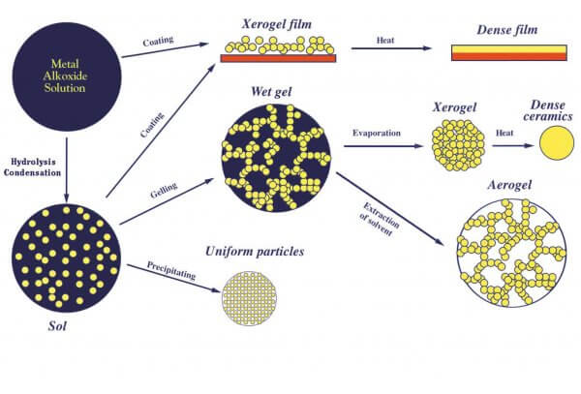

**Figure 3.1** Sol gel method

Here are two sol-gel methods most widely used in metal sulphides formation. The first approach focused on an altered sol-gel route involving a regular alcohol solution that is normally subjected to HZS from a sulfur source. The second include the application by modification of the first sol-gel route of thiols rather than alcohol for a sulphides synthesis. This process is widely used in the processing and development of nanorods, nano-particles, thin films and monoliths from inorganic and organic informative hybrid materials (Bousslama *et al.*, 2017).

* 1. **Lab equipment**

The beaker is made from the good type of glass have large round, hallow from inside and the level base. Furthermore, small curve beaker is used for the purpose of pouring liquid in another. We can see beaker in different size, shape and different capability. Most commonly beaker is used in standard size. Beakers we use in the lab made of glass. This glass is very reliable and can allow the high temperature. Some glasses are stiffer than steel or aluminum and some beakers made from definite type of plastic like PTFE, polythene and polypropylene. The beaker is made from the polypropylene is used to study the fluid of gamma analysis. Laboratory spatulas are small and generally made up of stainless steel. These are used for applying, scrapping and spreading of chemicals compounds in the form of paste of powders. Stainless steel is best for interaction with acids, bases and other chemicals because it resists deterioration. It is a small smooth cylindrical glass vessel with glass lid used for small amount of sample storing for short time. After cleansing, it can be recycled instead of scattering off. It is also used for sample drying purpose in oven. It is also heat tolerate at several hundred degree centigrade.

* + 1. **Electronic Balance**

Electronic balancing is defined as a method for electronics that is used to calculate mass in the smallest scale. Just the material weight, the air doesn't impact the measuring plate inside the electronic balanced plate effect. This measuring plate is called current protection. Switch the electronic balance to 0 degree first. For the rise of the material weight, the computer changes the material and calculates values. Machine only measures the weight of the chemical not air effect on the weight. The value of the chemical concentration in this calculation is correct.



**Figure 3.2** Electronic Balance

* + 1. **Magnetic Stirrer**

As an electronic unit, the magnetic stirrer is used as a mixer for magnetic solution and for the revolving use of a source for stir bar and mixes the solid chemical very rapidly in liquid form, it is also known as the magnetic mix. It is widely used in the chemical industry and its laboratories. The principal feature of the magnetic stirrer is where the solution is mounted in the beaker and the agitators spin in the loop. The magnet bar has the South Pole and the North Pole on two sides. Keep close to the bar to stirrer the bar with the help of electricity moving through the circle. The magnetic stirrer is used for small quantities and not for large amounts.



**Figure 3.3** Magnetic Stirrer

* + 1. **Oven**

Oven is an electronic system for heating the solution and beaker in labs and houses at consistent temperatures. More than this oven is used for various purposes depending on its temperature range. Oven which are used in laboratories have temperature range more than 340°C, in oven heat is absorbed by the resonance phenomenon. A range of frequency and wavelength is used during the resonance process.

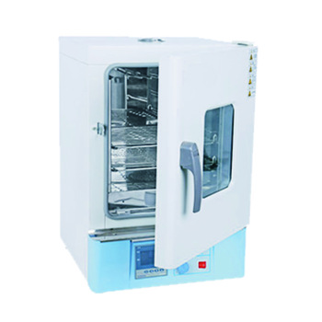

**Figure 3.4** Oven

* + 1. **Furnace**

Lab furnaces are used for complete water elimination from the sample. It is capable of heating at almost 1600 degree. Temperature can be maintained according to requirements. Its internal part is made up of ceramic substance that can tolerate high temperature. The furnace is used to dry the chemicals in which liquid have access amount. The temperature of the furnace goes to 400 degree centigrade to 1000 degree centigrade at which composites can dry. Some furnaces work with electricity because the gas furnace is hazardous for lab work. These are used for the crushing or grinding of dried samples. Come in various sizes and shapes. Samples are grinded until they become homogenous powder. Dropper is the kind of glass tube which has sharp knob on the edge and on the second end have the rubber sucker. By the dropper we can fill liquid in it and put it on another in the form of drops. It is made by glass and mostly use in labs.



**Figure 3.5** Furnace

* + 1. **Spin coater**

Spin coater is a mechanism that evenly distributes a liquid to a substrate. In this prototype spin-coater certain valuable properties such as the ability to create defect-free and uniform thin film, spinning precision with an integrated closed process chamber, etc. are retained. The materials used to produce thin film have been liquefied in a solvent. The device is designed here with a dc motor and a simple electronic circuit which allows easy control of the spinning speed. The spinning speed is up to 3,000 rpm in this design, which can be manually operated step by step. ZnO thin films are generated successfully by sol-gel method through this spin-coater. The thin film is a blend of Zinc oxides doped with strontium. This cost-efficient spin coater is a thin film deposition which is very simple and can be commonly used to treat films of uniform thickness.

* + 1. **Glass substrates**

The FTO is a translucent conduction oxide widely used in optoelectronic applications for Fluorine doped tin oxide (FTO). The FTO feature is generally referred to as 4.4eV, which is inconsistent with recent equipment output data. The authors calculated the function of commercial FTO in 5.0 + 0.1eV with x-ray photoelectron spectroscopy. Due to bending the surface band, UV ozone processing has been found to improve the working function by 0.1eV. The causes of the previously mentioned much lower features are also discussed and seen to be caused by carbon emissions and UV-inducing reduced operational functions.

* 1. **Precursors list for Strontium Doped Zinc Oxide.**

Zinc nitrate, Strontium Nitrate, DIO water, Ethanol, Ethylene Glycol etc.

* + 1. **Zinc nitrate**

Zinc nitrate is a naturally inorganic compound with that of the Zn (NO3)2 formula. This white, crystalline solid is extremely fragile and normally found as Zn (NO3)2.6H2O hexahydrate. In water as well as alcohol is soluble. Zinc nitrate is not used on a large-scale but is used for synthesis of coordinating polymers on a Lab scale. It is often used for the manufacture of different ZnO base structures, its regulated decomposition to zinc oxide.

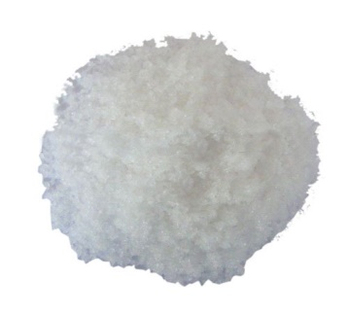

**Figure 3.6** Zinc nitrate Hexahydrate

* + 1. **Strontium Nitrate**

Strontium nitrate is an inorganic compound consisting of a formula Sr (NO3)2 in the elements strontium, nitrogen and oxygen. This color less solidifier is used in pyrotechnics as a red dye and oxidizer. Strontium nitrate is used, like all other strontium salts, to create a rich red blaze in the flames and flares of highways.

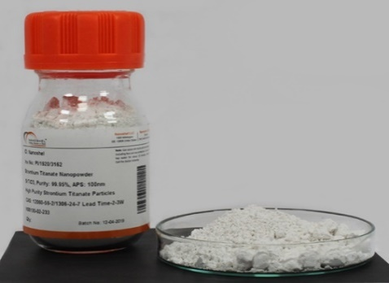

**Figure 3.7** Strontium nitrate hexahydrate

In these applications, the oxidizing properties of this salt are useful. Strontium nitrate can help eliminate and reduce skin irritation. When combined with glycolic acid, strontium nitrate greatly decreases skin inflammation rather than glycolic acid alone.

* + 1. **Ethylene Glycol**

A formula organic compound (CH2OH)2 is ethylene glycol. It is used mostly as a raw material in the manufacturing of polyester fabrics and in anti-freeze formulations for two purposes. It is smell less, colourless, sweet,

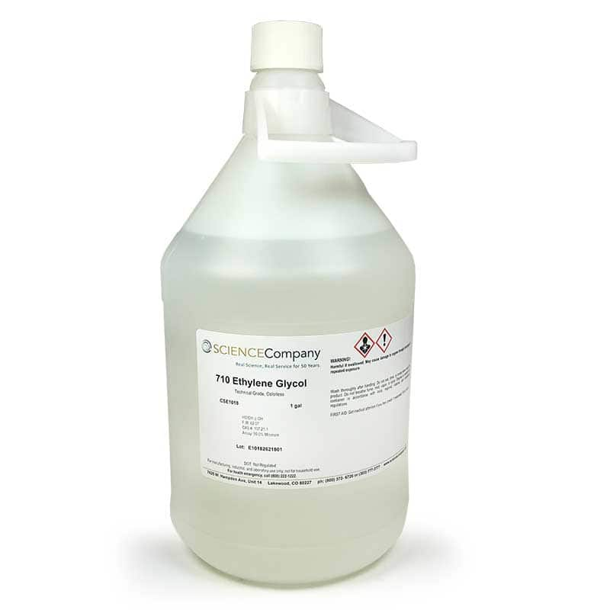

**Figure 3.8** Ethylene Glycol

* + 1. **Synthesis procedure**

The high-purity chemicals of over 99% were utilized. The precursors involved Zinc nitrate hexahydrate Zn (NO3)2, Strontium Nitrate hexahydrate Sr (NO3)2, are used for the precursors in this synthesis of Strontium doped zinc oxide Nanoparticles. No more purification was required. For the production of doped Nano-powder, zinc Nitrate Hexahydrate dissolved in 6ml of double distilled water and 4ml of ethanol were held in reserve under vigorous stirring on magnetic stirrer for 2 hours. Distinct buffer solutions was produced through process of dissolving Strontium nitrate hexahydrate in 10ml of double distilled water and were held in reserve under vigorous stirring on magnetic stirrer for 2 hours. Then this buffer was added up drop by drop to that initially prepared solution and was kept at room temperature under constant mixing for approximately 2 hours until there homogenous solution obtained. The finally obtained precipitates were then dried out in oven on the temperature of 80°C for 24 hours to get the gel The coating solvent (approx. 0.2 ml) was lowered and spin-coated with 3000 rev. min−1 for 20s in air after the layer was mounted on the discs of the spin-coater. This process created a precursor on the substrate material. After drying the precursor film, it was stored for 10 minutes in an electric oven at 80°C and then rinsed in the air in an electrical oven at 500-575°C for 20 minutes. This heating treatment decomposed and oxidized the precursor film to create the Zinc Oxides coating doped with Strontium. Finally, the experiments were carried out using a nm thick film Strontium doped Zinc Oxide. All other samples have also been produced with separate strontium concentration levels x= 0, 0.25, 0.50 and 0.75 using the same processing process.

* + 1. **Synthesis of ZnO**

Take a beaker and add 6ml deionized water after that 2.97g, 1.48g, 2.97g of zinc nitrate were respectively and 4ml ethanol was added in it. Solution was kept on magnetic stirrer for 2h to make homogenous solution. Zinc oxide solution was prepared after stirring.

**Flow Chart of ZnO**

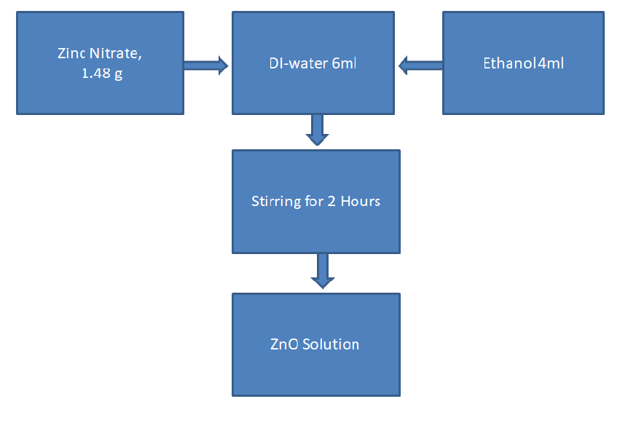

**Figure 3.9** Synthesis of ZnO

* + 1. **Synthesis of Strontium**

Take a beaker and add 10ml deionized water after that 0.53g, 1.06g, 1.59g of Strontium nitrate was respectively added in it. Solution was kept on magnetic stirrer for 2 h to make homogenous solution. Finally, zinc oxide solution was prepared after stirring.

**Flow Chart of Sr**

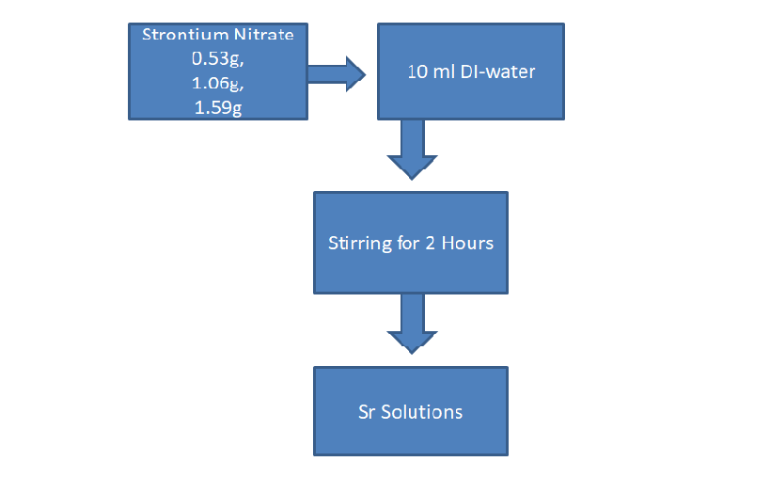

**Figure 3.10** Synthesis of Sr

|  |  |  |
| --- | --- | --- |
| **Sr** | **Strontium nitrate** | **Water** |
| **1** | 0.53 g | 10ml |
| **2** | 1.06 g | 10ml |
| **3** | 1.59 g | 10ml |

**Table 3.1** Synthesis of Sr nanoparticles

* + 1. **Synthesis Sr Doped ZnO**

Take a beaker and add a sample of ZnO solution after that 0.53g, 1.06g, 1.59g of Strontium nitrate was respectively added in it. Solution was kept on magnetic stirrer for 2 h to make homogenous solution. Finally, Sr doped zinc oxide solution was prepared after stirring.

**Flow Chart of Sr Doped ZnO**

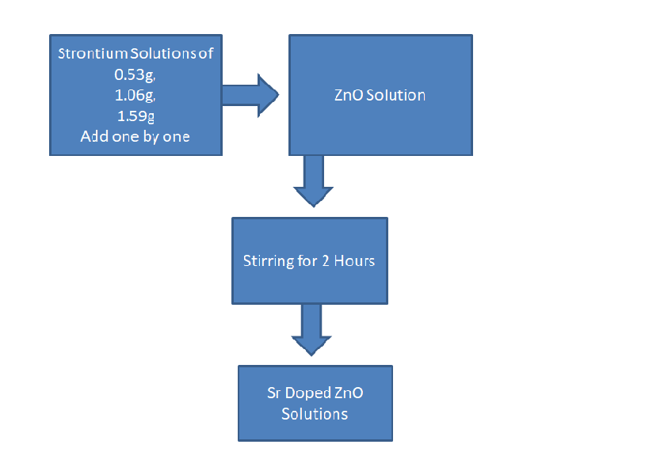

**Figure: 3.11** Synthesis process of Sr doped ZnO

* 1. **Characterization techniques**

The techniques used for the characterization and analysis of Sr doped ZnO are listed and discussed below:

* X-ray diffraction technique (XRD)
* Scanning electron microscopy (SEM)
* Ultra violet visible spectroscopy (UV-Vis)
* Energy Dispersive X-Ray Spectroscopy (EDX)
  + 1. **XRD-structural studies**

It is a swift method of investigation primarily used to detect a substance's process and is able to supply the corresponding values to cell unit dimension. The examined composition of the sample is tested homogenized, feebly grounded and common bulk.

* + 1. **Fundamental principles of XRD**

XRD has a foundation on which X-rays with a sound wavelength and crystalline sampling interferes constructively. These same wavelength X-rays are provided by a CRT cleaned for single wavelength radiation that has collimated towards the focus and is bound for the samples. The exchange of waves of events and samples constitutes a building block in order to satisfy the specifications of the Law of Bragg (nλ=2d Sinθ). This law connects EM radiation wavelength values, diffraction angles and lattice distance inside the crystalline sample. The diffracted X-rays are first interpreted, analyzed and then measured by a detector. The haphazard orientation of the powder type material is to be accomplished by scanning the sample positioned within the range of 20 angles and all likely directions for diffraction from the lattice. Altering the observed diffraction peaks to d-spacing allows the mineral to be found, as any mineral found has a certain number of d-spacing values. This is derived on average by comparing the normal values for the referenced patterns, d-spacing values of the compounds. The powder and single crystal put adjustments beyond this instrumentation. Figure: 3.12. Display XRD structure.

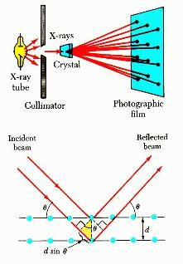

**Fig.3.12. X-ray Diffraction Technique**

* + 1. **XRD instrumentation and working**

X-ray diffract meter, composed of three, the major elements, an x-ray tube, a sample layer, an x-ray detector. The strands are heated to generate electrons, and then the electrons are accelerated into the direction of the target when they use voltage to bombard the target material. As these electrons, having sufficient energy, are formed, the characteristic form of X-ray spectrum consists of several components, to extract inner, shell electrons, from the target matter, the substance. Kα and Kβ species are most common. The type Kα1 and the type Kα2 are present. Kα1 has an almost shorter wavelength value, but the sensitivity of this form is twice as high as Kα2. The characteristic of the subject material is these unique wavelengths. The filtering process is carried out using the weighted average of the two used wavelengths which are sufficiently close. For e.g. copper is the most widely used u material with Cu kα radiation of 1.5418Å for single-crystal diffraction. These X-rays can be used on the observed sample. The intensity values of the reflected X-ray are collected after collection. Just as the geometry of such incident X-rays interfering with the sample is in accordance with the condition of the Bragg equation, so there is constructive interaction and various peaks of strength. The detector gathers and renovates the entire signal to the count rate, which is then used to provide the output of the system, after processing these ray signals.

* + 1. **Applications of XRD**

XRD is mainly commonly used for the identification of unspecified crystalline formed materials such as minerals and non-organic compounds. Detection of an unknown solid is definitive and central in the field of environmental, geographical, biological, material and engineering sciences.

**3.5 Scanning electron microscope (SEM)**

It is supposed to use a high energy electron ray to, produce a large range, of different signals, at the exterior layer of solid, samples. The signal values that are draw from sample electrons exchanges show the information related to the specimen involving exterior structural morphology like the texture, crystalline configuration, chemical composition and orientations of substances that make up that sample. In the majority of the functions, resultant data isgathered over a specific preferred area of sample facade and then the image having two dimensions is produced that presents the special kinds of variation in above mentioned qualities. Areas are generally ranging in the region of one centimeter to five microns in its “also be figured out in the scanning methods by means of the conventional SEM c. The exaggeration used for examination, was varied from 20X to 30,000X, the spatial declaration of 50nm to 100nm. The SEM is competent to carry out the analysis of point spots of the sample under observation; this technique is in particular useful to determine the chemical compositions, qualitatively or semi-quantitatively by using EDS, the crystal orientation, qualitatively or semi qualitatively by using EDS.

**3.5.1 Fundamental principle values of SEM**

The high speed electrons SEM hold major amount in kinetic energy that is dissolute as different ran range of signal values that produce through the sample-electron communication when most of the occasion electrons get slowed down in the sited solid images, diffracted back scattered electrons (EBSD) those can be utilized to find out the structures of crystals and mineral orientations, the backscattered electrons (BSE), the photons characteristic X-ray that can be utilized for the analysis of present elements and for variety X-ray, also for visible light i.e., cathodoluminescent-CL and heat. The secondary topography of models and the backscattered electrons also are most cooperative for the figure of the distinctions in the formation of multiphase samples for example for the discrimination of swift phase. X-rays are generated through the inelastic type collisions of occasion electron with the electron present in distinct orbital of different atoms in the placed example to observe. When these thrilled electrons come back to the lower states of energy, they produce X-rays. These X-rays are of unchanging wavelength and this wavelength is associated to variation in the values energy level values of different electrons present in different kinds of shells for the given component. So we can say, characteristic X-rays can be created for every factor present in the mineral and is excited through the incident electron ray. SEM investigation is regarded as “nondestructive” as the X-ray produced through the electron communications do not cause to short fall in the volume of given section, so it makes probable to examine the same thing repeatedly. The scanning electron microscope is shown in figure 3.13.

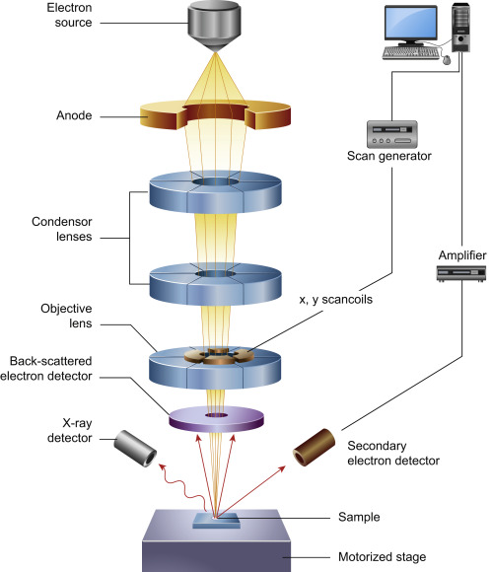

**Fig.3.13 Scanning, Electron, Microscope**

**3.5.2 SEM Applications**

This SEM is usually made in account to produce the elevated resolution image of the substances and also shows spatial changes in their chemical arrangements:

1. Obtaining elemental chart or to stain chemical analysis by, means, of EDS.
2. Disproportion of the segments stand on the mean atomic number by the means of BSE, usually related to the relative density.
3. Compositional charts that have foundation on the variations in the mark out element called "activators" by means of C means of CL, usually transition, metal and the rare-earth element.

**3.5.3 Strength of SEM**

There is possibly no any other device with wide applications for the study of the solid substances that are equivalent to SEM. The SEM is significant in different fields those call for categorization of the solid substances. Whereas this donation is mostly related with the geological functioning and it is noticeable that those workings are small fraction of the operatic and the industrial workings that subsist for this implementation. Most of SEMs are relatively straightforward to manage with the user-friendly intuitive interfaces. Here most applications need a less preparation of the sample. For most of the purposes, data achievement is frequent. The modern SEMs engender the data in a digital format and these are extremely convenient and expedient.

**3.6 Construction and working of UV-visible spectrometer**

A component diagram of a usual spectrometer is given in the following fig. 3.10. The implementation of the under discussion device is quite clear-cut. A light ray emerging from visible and/or a UV-light foundation (colored in red) are splatted up in its constituent wavelengths using a prism or a diffraction grating. Every monochromatic ray is then divided in two beams of equal strength of intensity through using a half mirrored instrument. One ray that is also called the sample beam (colored magenta) then happens to pass through a translucent container. This is a small container having a solution form of compound that is under discussion in the translucent solvent. The second beams also call the reference beam (colored blue) then happen to pass through like cuvette (container) that contains only solvent. Then the intensity values of all light rays are calculated through electronic detectors and then evaluated. The intensity value of reference beam, that should undergo no or a little light absorption, can be described as Io. The intensity value of sample ray is described as I. In a very little time, the spectrometer, instinctively start to scan all constituent wavelengths in the described way. The ultraviolet (UV) region inspected in general ranges from 200 nm to 400 nm, and value in visible portion ranges from 400nm to 800nm.

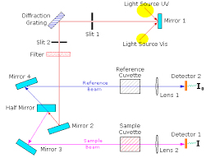

**Figure: 3.14** Diagram of a Spectrophotometer

The majority of the spectrometers show the absorbance values on the perpendicular axis and normally these ranges from 0 to 2. Where, the 0 means 100% transmittance and 2 means 1% transmittance. The value of wavelength for utmost absorbance is the characteristic assessment, denoted as IMAX. Figure: 3.12. Show diagram of spectrometer. Different compounds show different absorption values of maxima and also for absorbance values. The strongly absorbing substances should be inspected in the dilute solutions, so that a noteworthy amount of light energy may be gathered through the detector and this needs make use of non-absorbing, completely transparent solvents. The solvents frequently taken into account are, water, hexane, ethanol and cyclo-hexane. The solvents that have double or triple bonds or the profound atoms e.g. I, Br and S are usually avoided using process. The reason is that the absorbance value of the sample is in relation to its molar strength present in sample cuvette. An adjusted and standard absorption value called molar absorptive is utilized when we compare the spectral of different substances. The value of molar absorptivity’s are large enough for the sturdily absorbing substances that is e is greater than 10,000 and it is small if effect of absorption ability is fragile that is equal to 10 or up to 100.s

The visible region of the spectrum consists of the photons having energies from the range of 36kcal/mole to 72kcal/mole value. Near ultraviolet region not in range of 200 nm, expands this series of energy to 143 kcal/mole value. Ultraviolet radiation enclosing the wavelength values less than value of 200 nm is much hard to hold and is rarely utilized as usual tool for the structural examination. The existence of the chromospheres is excellently recognized through the UV-Visible spectroscopy technology, but there is a problem in the detection of the isolated chromophores and it is a collapse of most of devices to present absorption records for wavelength values below range of 200 nm. The magnitude of e shows chromophore size and also the possibility about the light of a certain specific wavelength will be immersed, when it will strike the chromophore. The study of absorption of UV-Visible optical spectral of the pure and Cu doped zinc oxide is conceded out at the ordinary temperature by use of UV-Visible spectrometer from the value of wavelength 350 nm to 600 nm. The absorption spectra value shows that absorption of the sample was declined with the increase in Cu concentrations excluding Cu value x = 0.06 that has a large value of absorption as compared all the other exemplary models. The value of absorption edge shows continuous red shift up to the value of Cu, x ≤ 0.04 which is because of the arrangement of some superficial level in the interior of band gap due to doping.

**CHAPTER 4**

**RESULTS AND DISCUSSIONS**

**4.1 SEM Analysis**

Scanning-electron microscopy is one of the major characterization techniques in the nano materials lab. For obtaining the detailed examination at a high-resolution SEM is performed and can be shown schematically. For obtaining the results with extremely small resolution are a big challenge, this challenge is achieved by using the SEM techniques. The presence of defects on the sample could also produce significant changes in the results of the samples which are obtained by different techniques. As object become smaller in size the efficiency of the SEM in producing the results with high resolution goes on increasing. As IC goes on thin, there is a great demand for using SEM when the properties become smaller in size then this could only be examined by different optical wavelengths. SEM is not only limited to imaging failures on IC’s and by the proper methods SEM can be used for studying the materials characterization technique. While studying the detailed observation of SEM, it uses many secondary electrons that are produce by the bombardment of samples with different electron beam in order to produce the image. This can be applied for having different surface roughness and can be calculated qualitatively. It is the basic analysis machine which is use top scan the surface of sample is kind of electron microscope the scientific name is SEM. In this machine the electron falls on sample then this electron reflects with information of samples surface and the composition. This reflected electron passes with the two magnetic lenses and enter in the detector which create image of sample. We use the Everhart Thornily detector to detect the secondary electron which is emitting from the sample which is very common in the SEM. After detecting secondary electron the detector check it intensity of specimen and the other things of specimen. The range of SEM is going to 100nm to 1nm which can give us good quality of image. The specimen we use tom take image place it in very high vacuum and high pressure to avoid the dust particles which are present in the environments.

**4.1.1 Principle**

The sign utilized by an examining electron magnifying instrument to deliver a picture result from cooperation of electron bar with molecules at different profundities inside the example. Different sorts of sign are delivered including optional electrons (SE), reflected or back-dissipated electrons (BSE), trademark X-beams and light, assimilated current and transmitted electrons. Optional electron finders are standard hardware in all SEMs, yet it is uncommon for a solitary machine to have indicators for all other potential signal. In scanning electron imaging, the auxiliary electrons are produced from near the specimen surface. Thus, SEI can create exceptionally high-resolution pictures of an example surface, uncovering subtleties under 1 nm in size. Back-dissipated electrons are bar electrons that are reflected from the example by flexible dispersing. They rise up out of more profound areas inside the specimen and, subsequently, the resolution of BSE picture is not as much as SE pictures. Be that as it may, BSE are frequently utilized in explanatory SEM, alongside the spectra produced using the trademark X-beams, because the power of the BSE sign is emphatically identified with the nuclear number of the specimen. BSE pictures can give data about the conveyance, yet not the character, of various components ion example. In tests prevalently made from light components, for example, natural specimens, imaging can picture colloidal gold immune-marks of 5 or 10 nm diameters, which would somehow be troublesome or difficult to identify in optional electron picture.

**4.1.2 SEM Images of Sr, ZnO**

SEM terminology shows the Sr, ZnO images in detail to study the surface morphology. Figure shows the SEM images of Sr, ZnO. Zinc Oxides demonstrated a layered Zinc sheet structure. Pure Zinc Oxides and Sr Doped Zinc oxides rose as a slender sheet with discrete edges, wrinkled surfaces and collapsing. The strontium sheets of the composites were clearly embellished with ZnO nanoparticles.

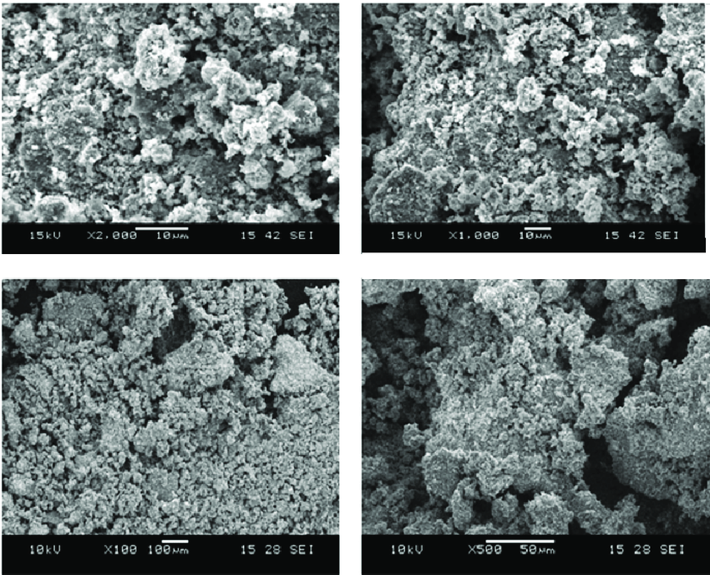

**Figure 4.1** SEM image of ZnO

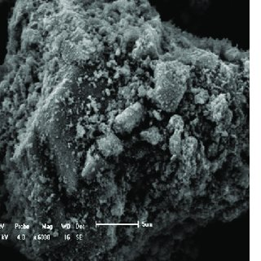

**Figure 4.2** SEM images of Strontium Nitrate Nanoparticles.

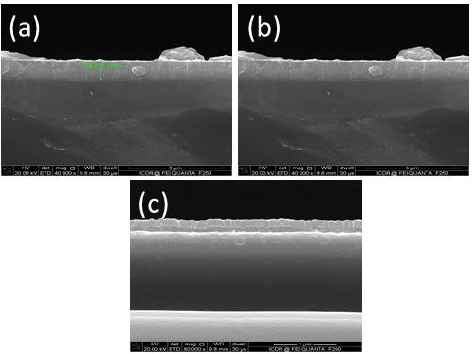

**Figure 4.3** SEM images of Strontium Doped ZnO Nanoparticles.

**4.2 XRD Analysis**

X-ray power diffraction is a fast-scientific procedure basically utilized for stage recognizable proof of a crystalline material and can give data on unit cell measurements. The discussed material is finely ground, homogenized, and normal mass arrangements are resolved.

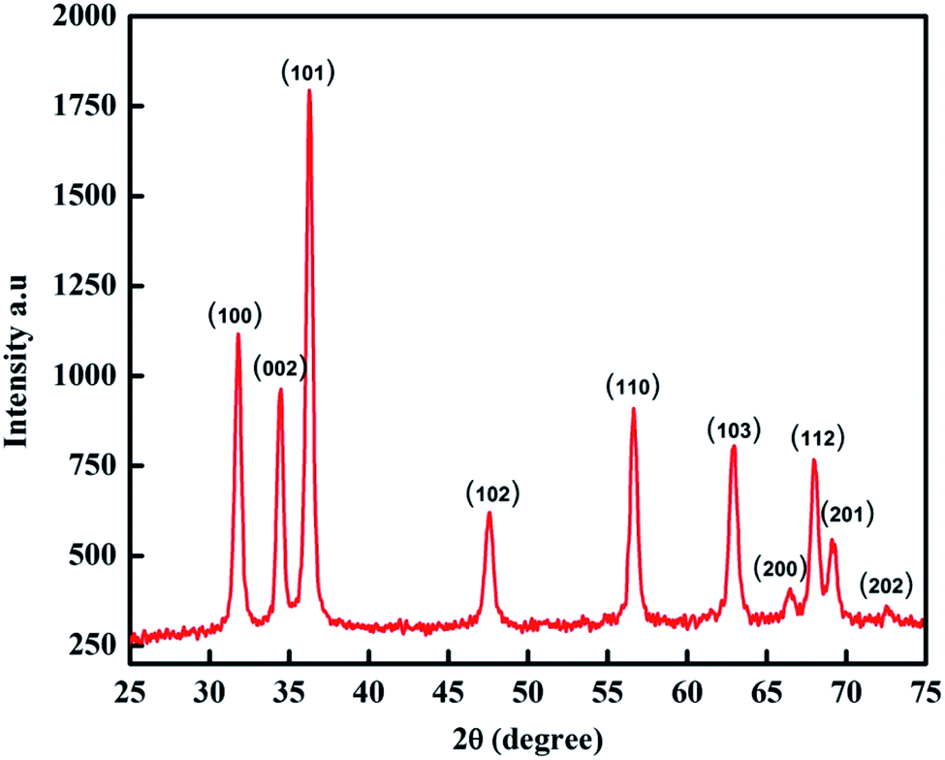

**Figure 4.4** XRD Analyses of Pure ZnO Nanoparticles

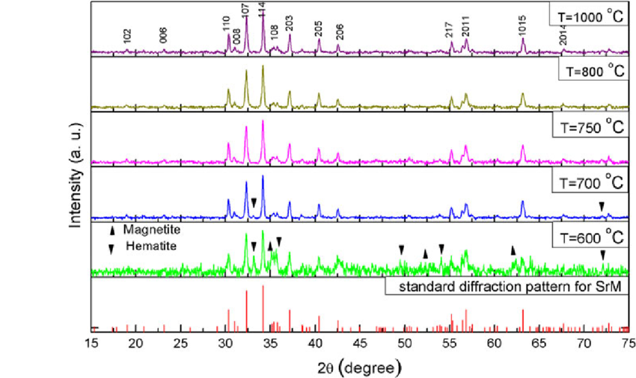

**Figure 4.5** XRD Analyses of Sr Nanoparticles

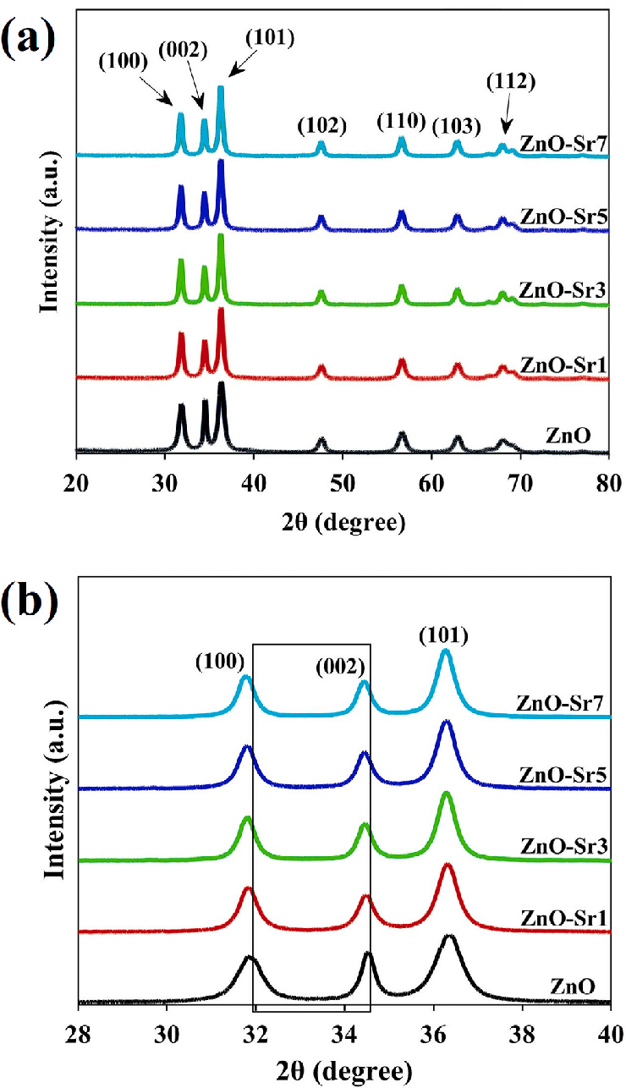

**Figure 4.6** XRD Analyses of Sr doped ZnO Nanoparticles

**4.3 Ultraviolet-Visible spectroscopy**

Ultraviolet visible spectroscopy alludes to assimilation spectroscopy or absorbance spectroscopy is part of the bright and the full, neighboring unmistakable unearthly areas. This implies it uses light in the noticeable and neighboring reaches In this locale of the electromagnetic range, particles and atoms experience electronic advances; ingestion spectroscopy is integral to fluorescence spectroscopy, in that fluorescence manages changes from the energized state to the ground state, while retention estimates the advances starting from the earliest stage to the energized state. The observational spectroscopy was used to locate and investigate the optical properties of prepared NPs, an effective non-destructive tool. The UV-Visible examines the pure zinc oxide (ZnO) and doping nanoparticles of zinc oxide. The visible UV spectrometer ranged between 360 and 380 nm. The substance then absorbs this light as the monochromatic light crosses an area. The absorption rate of the samples at various wavelengths is seen in Figure 4.7. The 0.25%, 0.5%, and 0.75% of the Strontium concentration illustrates the absorption figure. We are clearly aware of black line absorption is smaller than the blue line and extra blue line absorption is less, as the red line reveals increasing doping absorption.



**Figure 4.7** Ultraviolet-Visible Spectroscopy of Sr Doped ZnO

**4.4 EDX (Energy Dispersive X-Ray Spectroscopy)**

Energy dispersive X-ray spectroscopy is also called EDX; this technique is utilized for the elemental composition and chemical characterizations of the samples. It depends on the interaction between the sample and X-ray excitation bases. Different types of peaks are appeared in EDX because different element has specific atomic structure. An intensive beam of photons is focused on the sample for the elemental composition purpose. By using EDX, thickness of multilayer can also be determined. EDX is an analysis technique used for the elemental analysis or chemical characterizations of sample. It relies on an interaction of some source of X-ray excitation and each element has a unique atomic structure and asset of peaks on its electromagnetic emission spectrum. To stimulate the emission of characteristics X-rays from a beam of X-rays was focused into the sample being studied. At rest atom within the sample contains ground state electrons in discrete energy levels or electron shells bound to the nucleus.

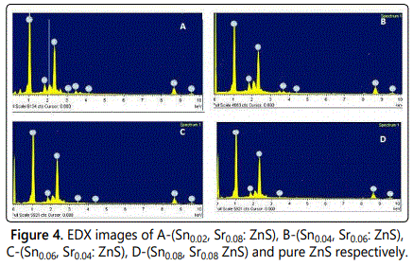

**Figure 4.8** EDX of Sr Doped ZnO

**4.5 Optical properties doped ZnO Nano powders**

A sharp band edge is observed at approximately 360 nm. As displayed by figure 4.9 which can be due to the intrinsic band gap absorption of ZnO due to the electrons transitions from the Valence Band to the Conduction Band. The onset of band edge absorption has been found to be blue shifted with decreasing particle size confirming the size dependent absorption properties of ZnO nanoparticles. A compressed lattice is expected to provide a wide band gap because of the increased repulsion between oxygen 2p and Zinc 4s bands. It is clear that with doped band gap was increased from 3.39 eV to 3.40 eV.

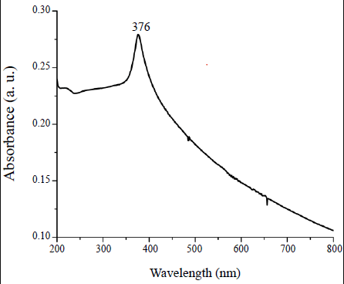

**Figure 4.9** UV-VIS spectra of ZnO nanoparticles



**Figure 4.10** UV-VIS Spectra of Doped ZnO Nanoparticles

**4.6 Photoluminescence studies**

Photoluminescence (PL) and optical absorption measurements are also extremely helpful for characterization of ZnO material. PL is very sensitive to the quality of crystal structure and the presence of defects. The band-to-band excitation of ZnO promotes electrons from the valence band to the conduction band, leaving holes in the valence band. The holes migrate from the valence band to deep levels and recombination occurs between electrons from either the conduction band or shallow donor levels and trapped holes on deep levels.

Usually, ZnO exhibits two visible bands centered at 510–540 nm (green emission) and 600-640 nm (yellow emission), attributed to oxygen vacancy and oxygen interstitial respectively. It has been suggested that the green emission is associated to oxygen deficiency, While the orange-red emission is associated to oxygen excess

Figure 4.10 depicts PL emission spectra for ZnO nano-powders. The spectra display and 540nm, representing weak UV and Visible emissions emissions centered at 385nm respectively. The UV luminescence peak corresponds to the near band edge emission and is commonly attributed to the recombination of excitons while the green emission peak is due to a deep level emission corresponding to the singly ionized oxygen vacancy in ZnO (oxygen related defects) resulting from recombination of a photon generated hole with the single ionized charged state of this defect. The first peak around 385nm corresponding to the near band edge (NBE) emission shifts to blue region with increasing doping. The intensity of doped ZnO decreased and band gap energy increased.

**CHAPTER 5**

**SUMMARY**

Strontium doped ZnO NPs in this research were organized by the sol-gel process. Zinc oxide has been prepared by a lot of methods such a while sol-gel method, hydrothermal method and spray paralysis method. But here the more preferred method for preparing zinc oxide is sol-gel method owing to its low-cost and ease of formation. Different steps are involved during the formation of Sr/ZnO nanoparticles. First, beakers of different volumes, sintering rods and then the flasks were cleaned through distilled water in front of initial manufacturing of the samples. It was performed to keep away from the contamination into the samples with a particular end goal. The zinc nitrate in a beaker, which was dehydrated about 2.97g was suspended into the 6ml distilled water and 4ml ethanol as well as prepared a 10ml solution called ‘A’. Into the other beaker, Strontium nitrate with the amount of 211.63g Deionized water as well as prepared a solution of 10ml, called this solution ‘B’. On self-supporting oppositely balanced strontium powder has gone through different steps like stirring, oven and furnace process. Zinc nitrate from another beaker with a quantity of 1.48g was mixed into the 6ml distilled water and 4ml ethanol which produced a solution of 10ml called ‘B’. During continuously stirring into the beaker, the two prepared ‘A’ and ‘B’ solutions were merged drop vise in Sample A. For every sample, concentration of the strontium nitrate was too different because of difference in molarities. This solution was continuously stirred so that the homogeneity of prepared solution can be easily maintained. Similar process was performed for every sample named as S1, S2 and S3. Then the final product was placed in china dish and dried for 24h in an electric oven at 80°C to get gel. Then that gel will be deposit on the FTO glass by using the spin coater. The spin coater having 3,000 rpm for deposit uniformly layer. The Glass substrate dried in oven at 100℃ for 30 mints, after that that sample Furnace on 500℃ to 550℃ for 10 mints. Sr/ZnO Nano composites which were prepared through this process have splendid efficiency of 95% under suitable conditions. Our results display the typical social affair of photovoltaic application of Sr-doped ZnO nanoparticles for solar cell applications. The obtained sample of Sr/ZnO was identified by using the different technique such as SEM, XRD UV-Vis spectroscopy.

**REFERENCES**

Ahmadi, A. and M. Noei. 2014. The alkali and alkaline earth metal doped ZnO nanotubes : DFT studies. Physica B: J. Condens. Matter Phys., 432: 105–110. Elsevier.

Alaria, J., P. Turek, M. Bernard, M. Bouloudenine, A. Berbadj and N. Brihi. 2005. No ferromagnetism in Mn doped ZnO semiconductors 415: 337–341.

Amornpitoksuk, P., S. Suwanboon, S. Sangkanu, A. Sukhoom, N. Muensit and J. Baltrusaitis. 2012. Synthesis , characterization , photocatalytic and antibacterial activities of Ag-doped ZnO powders modi fi ed with a diblock copolymer. Powder Technol., 219: 158–164. Elsevier B.V.

Anandan, S. 2007. Recent improvements and arising challenges in dye-sensitized solar cells. Sol. Energy Mater Sol, 91(9): 843–846.

Ba-abbad, M. M., A. Amir, H. Kadhum, A. Bakar and M. S. Takriff. 2013. Chemosphere Visible light photocatalytic activity of Fe 3 + -doped ZnO nanoparticle prepared via sol – gel technique. CHEMO,.

Baek, W., M. Choi, T. Yoon, H. H. Lee, Y. Kim, W. Baek, M. Choi, T. Yoon, H. H. Lee and Y. Kim. 2010. Use of fluorine-doped tin oxide instead of indium tin oxide in highly efficient air-fabricated inverted polymer solar cells Use of fluorine-doped tin oxide instead of indium tin oxide in highly efficient air-fabricated inverted polymer solar cells 133506: 10–13.

Bainbridge, W. S. 2002. Public attitudes toward nanotechnology ∗ 561–570.

Bamford, D. H. (n.d.) Virus structures : Those magnificent molecular machines 558–561.

Bandyopadhyay, P., A. Dey, R. Basu, S. Das and P. Nandy. 2014. SC. Curr Appl Phys. Elsevier Ltd.

Baskar, G. and S. Soumiya. 2016. Production of biodiesel from castor oil using iron ( II ) doped zinc oxide nanocatalyst. Renewable Energy, 1–7. Elsevier Ltd.

Bauer, C., G. Boschloo, E. Mukhtar and A. Hagfeldt. 2001. Electron injection and recombination in Ru(dcbpy)2(NCS)2 sensitized nanostructured Zno. J. Phys. Chem. B, 105(24): 5585–5588.

Bawendi, M. G. and L. Steigerwald. 1990. The Quantum Mechanics of Larger Semiconductor Clusters (" Quantum Dots ") (4): 477–496.

Baxter, J. B., A. M. Walker, K. Van Ommering and E. S. Aydil. 2006. Synthesis and characterization of ZnO nanowires and their integration into dye-sensitized solar cells. Nano. tech., 17(11).

Beverley, B. 1987. Observations on rearing karocolens pittospori (coleoptera: Curculionidae: Molytinae). N Z Entomol., 9(1): 34–37.

Bharadwaj, S. S., B. W. Shivaraj, H. N. N. Murthy and M. Krishna. 2018. ScienceDirect Synthesis and Characterization of Copper Doped Zinc Oxide Thin Films for CO Gas Sensing. Mater. Today., 5(10): 20904–20911. Elsevier Ltd.

Bousslama, W., H. Elhouichet and M. Férid. 2017. Enhanced photocatalytic activity of Fe doped ZnO nanocrystals under sunlight irradiation. Optik - light and electrons. Elsevier GmbH.

Brayner, R., R. Ferrari-iliou, N. Brivois, S. Djediat, M. F. Benedetti, F. Fie, P. Cedex and L. De Ge. (n.d.) Toxicological Impact Studies Based on Escherichia coli Bacteria in Ultrafine ZnO Nanoparticles Colloidal Medium 2–6.

Cai, K. F., X. R. He and L. C. Zhang. 2008. Fabrication , properties and sintering of ZnO nanopowder 62: 1223–1225.

Chen, H., J. Ding and S. Ma. 2010. Structural and optical properties of ZnO : Mg thin films grown under different oxygen partial pressures. Physica E Low Dimens. Syst. Nanostruct. 42(5): 1487–1491. Elsevier.

Chitra, M., K. Uthayarani, N. Rajasekaran and E. K. Girija. 2013. Preparation and characterisation of Al doped ZnO nanopowders. Phy. Procd., 49: 177–182. Elsevier B.V.

Ciciliati, M. A., M. F. Silva, D. M. Fernandes, M. A. C. De Melo, A. Adelina, W. Hechenleitner and E. A. G. Pineda. 2015. Fe-doped ZnO nanoparticles : Synthesis by a modi fi ed sol – gel method and characterization 159: 84–86.

D’Souza, L. P., R. Shwetharani, V. Amoli, C. A. N. Fernando, A. K. Sinha and R. G. Balakrishna. 2016. Photoexcitation of neodymium doped TiO2 for improved performance in dye-sensitized solar cells. Mater. Des, 104: 346–354. Elsevier B.V.

Dong, S., K. Xu, J. Liu and H. Cui. 2011. Photocatalytic performance of ZnO : Fe array films under sunlight irradiation. Physica B: J. Phys. Condens. Matter., 406(19): 3609–3612. Elsevier.

Drexler, E. 2007. “Nanoethics”? What’s New? (February): 22–25.

Editor, G., S. Pearton, S. Richeter, L. Raehm, B. L. Allen, M. B. Keddie and A. Star. 2010. This paper is published as part of a Nanoscale themed issue on doped nanostructures.

Forever, L. and M. Lundstrom. 2013. Moore ’ s Law Forever  210.

Foster, H. A., I. B. Ditta and S. Varghese. 2011. Photocatalytic disinfection using titanium dioxide : spectrum and mechanism of antimicrobial activity 1847–1868.

Fu, M., Y. Li, P. Lu, J. Liu and F. Dong. 2011. Applied Surface Science Sol – gel preparation and enhanced photocatalytic performance of Cu-doped ZnO nanoparticles. Appl. Surf. Sci. 258(4): 1587–1591. Elsevier B.V.

GaigeZheng. 2004. Nanoscience and nanotechnologies : opportunities and uncertainties.

Garcés, F. A., N. Budini, R. R. Koropecki and R. D. Arce. 2015. Structural Analysis of ZnO (: Al , Mg ) Thin Films by X-ray Diffraction. Procedia Materials Science, 8: 551–560. Elsevier B.V.

George, S., Œ. S. Pokhrel, Œ. T. Xia, Œ. B. Gilbert, Ќ. Z. Ji, M. Schowalter, A. Rosenauer, R. Damoiseaux, K. A. Bradley, L. Ma and E. Nel. 2010. Use of a Rapid Cytotoxicity Screening Approach To Engineer a Safer Zinc Oxide Nanoparticle through Iron Doping 4(1): 15–29.

Gherab, K., C. H. Voon, U. Hashim, M. Ameri and A. Bouhemadou. 2017. Aluminium nanoparticles size effect on the optical and structural properties of. Results Phys.,.

Giovannelli, F., A. N. Ndimba, P. Diaz-chao, M. Motelica-heino, P. I. Raynal, C. Autret and F. Delorme. 2014. Synthesis of Al doped ZnO nanoparticles by aqueous coprecipitation. Powder Technol., 262: 203–208. Elsevier B.V.

Giri, P. and P. Chakrabarti. 2016. Superlattices and Microstructures Effect of Mg doping in ZnO buffer layer on ZnO thin fi lm devices for electronic applications. Superlattices Microstruct., 93: 248–260. Elsevier Ltd.

Goel, S., N. Sinha, H. Yadav, A. J. Joseph and B. Kumar. 2017. Experimental investigation on the structural, dielectric, ferroelectric and piezoelectric properties of La doped ZnO nanoparticles and their application in dye-sensitized solar cells. Physica E: Physica E Low Dimens. Syst. Nanostruct., 91: 72–81. Elsevier B.V.

Greene, L. E., B. D. Yuhas, M. Law, D. Zitoun and P. Yang. 2006. Solution-grown zinc oxide nanowires. Inorg. Chem. 45(19): 7535–7543.

Gregg, B. A. 2017. Coulomb forces in excitonic solar cells. Organic Photovoltaics: Mechanisms, Materials, and Devices, 139–160.

Guerra, Y., R. Milani, D. M. Oliveira and F. R. De Souza. 2019. Influence of Ni and Sr on the structural , morphological and optical properties of ZnO synthesized by sol gel 98.

Helander, M. G., M. T. Greiner, Z. B. Wang, W. M. Tang, Z. H. Lu, M. G. Helander, M. T. Greiner, Z. B. Wang and W. M. Tang. 2014. Work function of fluorine doped tin oxide 011019(2011): 25–29.

Huang, L., L. Cheng, S. Pan, Y. He, C. Tian, J. Yu, L. Cheng, S. Pan, Y. He, C. Tian, J. Yu and H. Zhou. 2020. Jo ur of.

Ignatovich, F. V and L. Novotny. 2006. Real-Time and Background-Free Detection of Nanoscale Particles 013901(January): 1-4.

Jayabharathi, J., C. Karunakaran, V. Kalaiarasi and P. Ramanathan. 2014. Journal of Photochemistry and Photobiology A : Chemistry Nano ZnO , Cu-doped ZnO , and Ag-doped ZnO assisted generation of light from imidazole. ‘J. Photochem. Photobiol. A’, 295: 1–10. Elsevier B.V.

Jayasimhadri, M., K. Jang, H. S. Lee, B. Chen, S. Yi, M. Jayasimhadri, K. Jang, S. Lee, B. Chen and S. Yi. 2009. White light generation from Dy3 + -doped ZnO – B2O3 – P2O5 glasses 013105.

Jeevanandam, J., A. Barhoum, Y. S. Chan, A. Dufresne and M. K. Danquah. (n.d.) Review on nanoparticles and nanostructured materials : history , sources , toxicity and regulations :1050–1074.

Jongnavakit, P., P. Amornpitoksuk, S. Suwanboon and N. Ndiege. 2012. Applied Surface Science Preparation and photocatalytic activity of Cu-doped ZnO thin films prepared by the sol – gel method. Appl. Surf. Sci. 258(20): 8192–8198. Elsevier B.V.

Kamat, P. V. 2008. Quantum dot solar cells. Semiconductor nanocrystals as light harvesters. J. Phys. Chem. 112(48): 18737–18753.

Kawashima, T., H. Matsui and N. Tanabe. 2003. New transparent conductive films : FTO coated ITO 445(03): 241–244.

Khan, R. N., N. Ali, S. Riaz and S. Naseem. 2015. Effect of calcination on properties of cobalt doped ZnO nanoparticles. Materials Today: Proceedings, Vol. 2. Elsevier Ltd.

Khanafer, K. and K. Vafai. (n.d.) Applications of Nanomaterials in Solar Energy and Desalination Sectors. Adv. Heat Transf., 1st ed., 45. Copyright © 2013 Elsevier Inc. All rights reserved.

Kinosita, K. and K. Adachi. 2004. R Otation of F 1 -ATP ASE : How an ATP-Driven Molecular Machine May Work.

Kolodziejczak-Radzimska, A. and T. Jesionowski. 2014. Zinc oxide-from synthesis to application: A review. Mater. Lett, 7(4): 2833–2881.

Kong, F. T., S. Y. Dai and K. J. Wang. 2007. Review of recent progress in dye-sensitized solar cells. Advances in OptoElectronics, 2007.

Kong, L., Y. Bao, W. Guo, L. Cheng, J. Du, R. Liu, Y. Wang, X. Fan and C. Tao. 2016. Low-cost zinc-plated photoanode for fabric-type dye-sensitized solar cells. Appl. Surf. Sci 363: 323–327. Elsevier B.V.

Le, T. H., A. T. Bui and T. K. Le. 2014. The effect of Fe doping on the suppression of photocatalytic activity of ZnO nanopowder for the application in sunscreens. Powder Technology, 268: 173–176. Elsevier B.V.

Lee, C. P., C. T. Li, M. S. Fan, S. R. Li, Y. J. Huang, L. Y. Chang, C. M. Tseng, S. S. Sun, J. J. Lin and K. C. Ho. 2016. Microemulsion-assisted Zinc Oxide Synthesis: Morphology Control and Its Applications in Photoanodes of Dye-Sensitized Solar Cells. Electrochimica Acta, 210: 483–491. Elsevier Ltd.

Li, Q., S. Mahendra, D. Y. Lyon, L. Brunet, M. V Liga, D. Li and P. J. J. Alvarez. 2008. Antimicrobial nanomaterials for water disinfection and microbial control : Potential applications and implications. Water Research, 42(18): 4591–4602. Elsevier Ltd.

Lieber, C. M. 2003. N anoscale Science and Technology : Building a Big Small Things: 486–491.

Lim, S. H., Z. Luo and Z. Shen. 2010. Plasma-Assisted Synthesis of Carbon Nanotubes Plasma-Assisted Synthesis of Carbon Nanotubes.

Liu, Y., J. Yang, Q. Guan, L. Yang and Y. Zhang. 2009. Effects of Cr-doping on the optical and magnetic properties in ZnO nanoparticles prepared by sol – gel method 486: 835–838.

Liu, Z., Y. Li, C. Liu, J. Ya, W. Zhao, L. E, D. Zhao and L. An. 2011. Performance of ZnO dye-sensitized solar cells with various nanostructures as anodes. Solid State Sciences, 13(6): 1354–1359.

Louiza, A., H. Saliha, H. Sofiane, G. Kamel and G. Lakhder. 2012. Structural and luminescence properties of pure and Al-doped ZnO nanopowders. Mater. Sci. Eng. B, 177(11): 902–907. Elsevier B.V.

Maldonado, F. and A. Stashans. 2010. Journal of Physics and Chemistry of Solids Al-doped ZnO : Electronic , electrical and structural properties. J Phys Chem Solids, 71(5): 784–787. Elsevier.

Mammen, M., S. Choi and G. M. Whitesides. (n.d.) Polyvalent Interactions in Biological Systems : Implications for Design and Use of Multivalent Ligands and Inhibitors **.

Manuscript, A. 2013. J. Mater. Chem. B (207890).

Marsh, K. N., S. Pang and M. P. Staiger. 2009. Ionic Liquids and Their Interaction with Cellulose 6712–6728.

Moontragoon, P., S. Pinitsoontorn and P. Thongbai. 2013. Microelectronic Engineering Mn-doped ZnO nanoparticles : Preparation , characterization , and calculation of electronic and magnetic properties. Microelectron Eng. (February): 1–5.

Mulkens, J., J. Mcclay, B. Tirri, M. Brunotte, B. Mecking, H. Jasper and C. Zeiss. (n.d.) Optical lithography solutions for sub-65 nm semiconductor devices . 5040(2003): 753–762.

Naik, E. I., H. S. B. Naik, R. Viswanath, B. R. Kirthan and M. C. Prabhakara. 2020. Effect of zirconium doping on the structural , optical , electrochemical and antibacterial properties of ZnO nanoparticles prepared by sol-gel method. Chem. Data Collect. 29: 100505. Elsevier B.V.

Nair, M. G., M. Nirmala, K. Rekha and A. Anukaliani. 2011. Structural , optical , photo catalytic and antibacterial activity of ZnO and Co doped ZnO nanoparticles. Mater. Lett. 65(12): 1797–1800. Elsevier B.V.

Oves, M., M. Arshad, M. S. Khan, A. S. Ahmed, A. Azam and I. M. I. Ismail. 2015. Anti-microbial activity of cobalt doped zinc oxide nanoparticles : Targeting water borne bacteria. J. Saudi Chem. Soc. 19(5): 581–588. King Saud University.

Paul, D. R. and L. M. Robeson. 2008. Polymer nanotechnology : Nanocomposites. Polymers with aligned carbon nanotubes: Active composite materials, 49(15): 3187–3204. Elsevier Ltd.

Phoenix, C. and E. Drexler. (n.d.) Safe exponential manufacturing 869.

Pradeev, K., K. Sadaiyandi, A. Kennedy, S. Sagadevan, Z. Z. Chowdhury, M. Rafie, B. Johan, F. A. Aziz, R. F. Rafique, R. T. Selvi and R. Rathina. 2018. Influence of Mg Doping on ZnO Nanoparticles for Enhanced Photocatalytic Evaluation and Antibacterial Analysis. Nanoscale Res. Lett..

Publishing, P., O. R. Text, A. G. Morachevskii and I. N. Beloglazov. 2006. REVIEWS Translated under the title Nanotekhnologiya 79(7): 1213–1214.

Qureshi, M. T. 2018. Structural and Optical Properties of Pure and Copper Doped Zinc. Results Phys.,.

Raj, K. P., K. Sadaiyandi, A. Kennedy and R. Thamizselvi. 2016. Structural , optical , photoluminescence and photocatalytic assessment of Sr-doped ZnO nanoparticles. Mater. Chem. Phys., 183: 24–36. Elsevier B.V.

Rama Krishna, C. and M. Kang. 2017. Improving the photovoltaic conversion efficiency of ZnO based dye sensitized solar cells by indium doping. J. Alloys Compd. 692: 67–76. Elsevier Ltd.

Rao, K. S. and T. Vanaja. 2015. Influence of Transition Metal ( Cu , Al ) ions Doping on Structural and Optical properties of ZnO Nanopowders 2: 3743–3749.

Rao, P. R., G. M. Krishna, M. G. Brik, Y. Gandhi and N. Veeraiah. 2011. Fluorescence features of Sm 3 + ions in Na 2 SO 4 – MO – P 2 O 5 glass system — Influence of modifier oxide. J. Lumin. 131(2): 212–217. Elsevier.

Rekha, K., M. Nirmala, M. G. Nair and A. Anukaliani. 2010. Structural , optical , photocatalytic and antibacterial activity of zinc oxide and manganese doped zinc oxide nanoparticles. Physica B: J. Phys. Condens. Matter. 405(15): 3180–3185. Elsevier.

Rouchdi, M., E. Salmani, B. Fares, N. Hassanain and A. Mzerd. 2017. Results in Physics Synthesis and characteristics of Mg doped ZnO thin films : Experimental and ab-initio study. Results Phys., (January): 1–8.

Roy, A., S. Maitra, S. Ghosh and S. Chakrabarti. 2016. Sonochemically synthesized iron-doped zinc oxide nanoparticles : In fl uence of precursor composition on characteristics. Mater. Res. Bull. 74: 414–420. Elsevier Ltd.

Saa, A., R. Yousefi, A. K. Zak and M. R. Mahmoudiand. 2015. Author ’ s Accepted Manuscript. Physica E: Physica E Low Dimens. Syst. Nanostruct,. Elsevier.

Search, H., C. Journals, A. Contact, M. Iopscience and I. P. Address. 2009. Effect of alkaline earth metal doping on thermal , optical , magnetic and dielectric properties of BiFeO 3 nanoparticles 065004.

Search, H., C. Journals, A. Contact, M. Iopscience and I. P. Address. 2011. Towards large-scale plasma-assisted synthesis of nanowires 174014.

Shang, D. S., L. Shi, J. R. Sun, B. G. Shen, F. Zhuge, R. W. Li, Y. G. Zhao, D. S. Shang, L. Shi, J. R. Sun, B. G. Shen, F. Zhuge, R. W. Li and Y. G. Zhao. 2010. Improvement of reproducible resistance switching in polycrystalline tungsten oxide films by in situ oxygen annealing Improvement of reproducible resistance switching in polycrystalline tungsten oxide films by in situ oxygen annealing 072103: 21–24.

Shanthi, S. I., S. Poovaragan, M. V Arularasu, S. Nithya and R. Sundaram. 2018. Li , Mg and Sr Doped and Undoped Zinc 18(8): 5441–5447.

Sharma, N., S. Jandaik, S. Kumar and M. Chitkara. 2015. Synthesis , characterisation and antimicrobial activity of manganese- and iron-doped zinc oxide nanoparticles (April): 37–41.

Sharma, N., J. Kumar, S. Thakur and S. Sharma. 2013. Antibacterial study of silver doped zinc oxide nanoparticles against Staphylococcus aureus and Bacillus subtilis. Drug Invention Today, 5(1): 50–54. Elsevier Ltd.

Sheehan, S., P. K. Surolia, O. Byrne, S. Garner, P. Cimo, X. Li, D. P. Dowling and K. R. Thampi. 2015. Solar Energy Materials & Solar Cells Flexible glass substrate based dye sensitized solar cells 132: 237–244.

Shenhar, R. O. Y. and V. M. Rotello. 2003. Nanoparticles : Scaffolds and Building Blocks 36(7): 549–561.

Shrisha, B. V, S. Bhat, D. Kushavah and K. G. Naik. 2016. ScienceDirect Hydrothermal growth and characterization of Al-doped ZnO nanorods. Materials Today: Proceedings, 3(6): 1693–1701. Elsevier Ltd.

Silva, A. M. B., R. N. Correia, J. M. M. Oliveira and M. H. V Fernandes. 2010. Structural characterization of TiO 2 – P 2 O 5 – CaO glasses by spectroscopy 30: 1253–1258.

Silva, G. A., M. Sc and D. Ph. 2004. Introduction to Nanotechnology and Its Applications to Medicine.

Singh, F. 2016. SC. J. Alloys Compd.. Elsevier Ltd.

Singhal, S., J. Kaur, T. Namgyal and R. Sharma. 2012. Cu-doped ZnO nanoparticles : Synthesis , structural and electrical properties. Physica B: J. Phys. Condens. Matter 407(8): 1223–1226. Elsevier.

Soni, D., P. Parsoya, B. K. Menariya, R. Vyas and R. Ameta. 2015. Photoelectrochemical cells. Solar Energy Conversion and Storage: Photochemical Modes, 414(November): 29–53.

Sonker, R. K., S. Sikarwar, S. R. Sabhajeet, Rahul and B. C. Yadav. 2018. Spherical growth of nanostructures ZnO based optical sensing and photovoltaic application. Optical Materials, 83(May): 342–347. Elsevier.

Srivastava, V. C. 2013. Photocatalytic Oxidation of Dye Bearing Wastewater by Iron Doped Zinc Oxide.

Stubhan, T., H. Oh, L. Pinna, J. Krantz, I. Litzov and C. J. Brabec. 2011. Inverted organic solar cells using a solution processed aluminum-doped zinc oxide buffer layer. Organic Electronics, 12(9): 1539–1543. Elsevier B.V.

Suwanboon, S., P. Amornpitoksuk, A. Haidoux and J. C. Tedenac. 2008. Structural and optical properties of undoped and aluminium doped zinc oxide nanoparticles via precipitation method at low temperature 462: 335–339.

Thaweesaeng, N., S. Supankit and W. Techidheera. 2013. Structure Properties of As-synthesized Cu-doped ZnO Nanopowder Synthesized by Co-precipitation Method. Energy Procedia, 34: 682–688. Elsevier B.V.

Vidyanandan, K. V and S. Member. 2017. An Overview of Factors Affecting the Performance of Solar PV Systems (February).

Vittal, R. and K. C. Ho. 2017. Zinc oxide based dye-sensitized solar cells: A review. Renewable and Sustainable Energy Reviews, 70(December 2016): 920–935. Elsevier Ltd.

Vorkapic, D. and T. Matsoukas. 1998. Effect of Temperature and Alcohols in the Preparation of 20: 2815–2820.

Wang, K. L. 2002. Issues of Nanoelectronics : A Possible Roadmap Review 235–266.

Wang, X., L. Zhi and K. Mu. 2008. Transparent , Conductive Graphene Electrodes for Dye-Sensitized Solar Cells.

Whitesides, G. M. 2005. essays 172–179.

Wilson, W. W., M. M. Wade, S. C. Holman and F. R. Champlin. 2001. Status of methods for assessing bacterial cell surface charge 43: 153–164.

Wojnarowicz, J., S. Kusnieruk, T. Chudoba, S. Gierlotka, W. Lojkowski, W. Knoff, M. I. Lukasiewicz, B. S. Witkowski, A. Wolska, M. T. Klepka, T. Story and M. Godlewski. 2015. Paramagnetism of cobalt-doped ZnO nanoparticles obtained by microwave solvothermal synthesis 1957–1969.

Wu, M., W. Chen, S. Chan and W. Su. 2018. Applied Surface Science The effect of strontium and barium doping on perovskite-structured energy materials for photovoltaic applications. Applied Surface Science, 429: 9–15. Elsevier B.V.

Xia, T., Y. Zhao, T. Sager, S. George, S. Pokhrel, N. Li, D. Schoenfeld, H. Meng, S. Lin, X. Wang, M. Wang, Z. Ji, J. I. Zink, M. Lutz, V. Castranova, S. Lin and A. E. Nel. 2011. Decreased Dissolution of ZnO by Iron Doping Yields Nanoparticles with Reduced Toxicity in the Rodent Lung and Zebra fi sh Embryos (2): 1223–1235.

Xiao, W., S. Member, N. Ozog, S. Member, W. G. Dunford and S. Member. 2007. Topology Study of Photovoltaic Interface for Maximum Power Point Tracking 54(3): 1696–1704.

Yeh, C. S., C. C. Kuo, B. R. Huang and S. Dhar. 2005. Optical and Transport Properties Of Undoped And Al- , Ga- and In-Doped ZNO Thin Films 7(6): 3039–3046.

Yoo, R., D. Li, H. J. Rim, S. Cho, H. Lee and W. Lee. 2018. PT SC. Sens. Actuators B Chem. Elsevier B.V.

Yousefi, R., F. Jamali-Sheini, M. Cheraghizade, S. Khosravi-Gandomani, A. Sáaedi, N. M. Huang, W. J. Basirun and M. Azarang. 2015. Enhanced visible-light photocatalytic activity of strontium-doped zinc oxide nanoparticles. Mater Sci Semicond Process 32: 152–159.

Yousefi, R., A. K. Zak and F. Jamali-sheini. 2013. The effect of group-I elements on the structural and optical properties of ZnO nanoparticles. Ceram. Int. 39(2): 1371–1377. Elsevier.

Zno, C. F. 2017. Author ’ s Accepted Manuscript. Mod. Electron. Mater.. Elsevier B.V.